Business Blueprint
Cargill Vietnam

Commercial in Confidence
Author | Sajith Punathil
Date | 8th June 2015
Review Date
Document Ref | GV00004676
Current Ver | 1.0
PF3100 Document Release Notice

Confidentiality
The information contained in this document is privileged and confidential, and remains the intellectual property of Automatic Data Processing, Inc. and/or its affiliates ("ADP Group "). This document must not be reproduced, stored in a retrieval system, or transmitted in any form by means electronic, mechanical, optical, photocopying, recording or otherwise, without the prior consent of ADP. This document must be kept strictly confidential at all times. It must not be disclosed to any person without the prior written consent of the ADP Group.
ADP is a registered trademark and service mark of ADP of North America, Inc. GLOBALVIEW is a registered trademark and service mark of ADP, Inc.
© Copyright 2007 ADP, Inc.

Amendments in this release:
Version | Authored | Approved | # of CRM Ticket requesting for upload | Next Review Date
Client Authorization
Approved:  Cargill Country Project Lead | Signature | Name | Date
Approved:  Cargill Country Project Lead |  | HoaiVy Nguyen
Authorised:  Cargill Regional Project manager | Signature | Name | Date
Authorised:  Cargill Regional Project manager |  | Daniel Sun
Authorised:  Cargill Program Lead | Signature | Name | Date
Authorised:  Cargill Program Lead |  | Deana Chang
Authorised:  ADP Project Manager | Signature | Name | Date
Authorised:  ADP Project Manager |  | Patrick Heartier

Table of Contents
Confidentiality ii
Amendments in this release: ii
Purpose of Business Blueprint 1
Global and Local Template Definitions 1
Scope of Country Implementation 2
Overview of Company Structure 2
Business Processes 2
Current Payroll Solution 2
Current Payroll Processes 2
General – Tracking Employees 3
GlobalView Payroll Number 3
1. GlobalView assigns Payroll Number 3
2. Country Transfer 3
3. Company Transfer within Vietnam 3
Company Definitions 5
Basic Salary/ Package Definition 5
Cost Centre Structure 6
Expatriate/ International Assignee/ Other (regional definitions) 6
Configuration Definitions 6
Company Code Structure 6
Enterprise Structure (Branch Structure) 7
Employee Group Structure (Employment Terms) 7
Pay Frequency 7
Groupings [PSG & ESG] 8
Personnel Sub-area Grouping [PSG]: 8
Employee Subgroup Grouping [ESG]: 8
Payscale Structure 8
Rates of Pay 9
Prorating Rules 10
Payments 12
Deductions 28
Holiday Calendar 30
Work Patterns 32
Absences 34
Absence Quotas 36
Social Insurance 38
Technical WT Reference 41
Taxation 41
Any changes to the above constant will be updated automatically in system as part of legal update. 42
Tax finalization will be configured for Cargill in every “January” Payroll. 45
Banking 45
General Ledger 46
User Access 46
Configuration Worksheet 47
Reports Provided 47
Country Specific Reports 48
Period Reports 48
Year End Reports 48
Payslip 49
Employee Self Service 49
Interfaces 50
The Client will send the following inbound interfaces 50
ADP will provide the following outgoing interfaces – 50
Assumptions/Risks 50
Assumptions 50
Risks 50
GAP Analysis and Resolution 50
Missing Functionality 50
System Modifications Required 50
Appendices 51

Purpose of Business Blueprint
The ADP Business Blueprint provides the basis for setup and testing of the GlobalView® ES solution during realization and subsequent phases of project implementation. It will also document the terminology, definitions, groupings and other categorisations required for the successful implementation of the GlobalView® service for the benefit of both parties.
The Business Blueprint will not include all of the details described in subsequent ADP documentation including the Implementation Plan, Data Conversion Plan, etc., which are generally developed later in the implementation process, on the basis of details provided in the Business Blueprint.
The complete list of entries referred to in this document is provided by the Blueprint Configuration Worksheet, a copy of which is included. Generally speaking, the section headings in this document will correspond with Worksheet Tabs in the Blueprint Configuration Worksheet.
ADP Consultant: please ensure that adequate descriptions and ‘real-life’ examples which clearly describe the client company’s business processes, are provided in each relevant section.
Global and Local Template Definitions
The Business Blueprint describes the functional scope and the design decisions that have been made by during the blueprint workshops for the Cargill Vietnam implementation. However it needs to be understood that the Global Template Document describes the global decisions which have already been taken for Cargill and that the Business Blueprint is required to conform with the global design in respect of processes and global data definitions. Therefore, all data and field entries which have been designated as ‘global’ need to be treated as such, to facilitate consistent, global conventions and reporting.

In case of a conflict between the Global Template Document and the local Business Blueprint, the Global Template Document takes precedence, except for in a case where the Global Template Document needs to be updated in accordance with a requirement that emerges during the country Business Blueprinting process.

The Business Blueprint will therefore describe the implementation of processes and data which are by definition ‘local’, or country-specific. The Business Blueprint will also document any additions and gaps between the local requirements and the Global Template document, if required.

91010411
91010412
91010413
91010414
91010415

Scope of Country Implementation
ADP GlobalView is to provide Managed Service (MS) for Cargill Vietnam.
The modules of ADP ES’ GlobalView solution that are in scope for this country are as follows:
- Personnel Administration
- Payroll (country)
- Time Management (Leave Management)
- Employee/Manager Self Service

The modules that are out of scope for this country are:
- Human Resources

Each of these modules will be blueprinted separately, if required.
Overview of Company Structure
The Cargill Vietnam has 2 legal entities.
Co Code | Company Name | Abbreviation
VN10 | Cargill Vietnam LTD | CVL / 1237
VN20 | Provimi Vietnam LTD | CPN / 1244

For the purpose of this blueprint, it will be assumed that unless specified, the Blueprint is consistent across all companies. Should any of the individual sites require special rules; this will be clearly indicated in the document.

Business Processes

Current Payroll Solution
HR – OMPA (SAP)
Payroll – Excel based calculation
GL - JDE

Current Payroll Processes
Cargill Vietnam store HR data in OMPA; and data from OMPA and time sheet data received from each location will be used for payroll calculation. All payroll calculations are done in MS-Excel and payroll period for the calculation is 21st of previous month to 20th of the current month. The Pay date is last working day of the month. Bank files are loaded into Bank system on the Pay date.

Please refer attached document which elaborate current payroll processing procedures in Cargill Vietnam.


General – Tracking Employees

GlobalView Payroll Number

1. GlobalView assigns Payroll Number
All Cargill employees will be assigned a unique GlobalView Payroll Number (GV PERNR) which will be different to their current Cargill employee ID. However, reference to the employee ID will be maintained in the GlobalView system, so employees will continue to see it on their payslips and the Cargill payroll team will be able to access it in the GlobalView system, if required.
Both inbound and outbound interfaces will continue to reference the Cargill employee ID, if required.
Payroll reporting will be based on the GlobalView Payroll Number however Cargill employee ID also will be able to insert/refer in most of the payroll reports.

2. Country Transfer
The GlobalView Payroll Number is country-specific, so that if an employee is transferred to a new country a new GV PERNR number will be generated. In the event of return to a country in which they have previously been employed, the previous GV PERNR will be re-used.
When an employee is transferred to a new country, the ADP interface program will identify the change in the country code and will generate a GV PERNR for use in the new country. As above, however, employee’s Cargill SAP ID may be maintained in the system for reference.

3. Company Transfer within Vietnam

In ADP GV, there are two solutions to handle legal entity transfer of employees within the country.
- Option 1 - Organizational Transfer action is used.
This option can be only used if the transfer is done at the beginning (1st) of the month. For the transfer in the middle of the month, this approach cannot be used.
  - No Termination payroll is processed in this option.
  - Employee will be able to view their previous payslip and leave history without any cut off.
  - No split reporting - From current payroll onwards, all Income and deduction will be reported in new legal entity only
  - All auto calculation (Bonus, severance, leave balance) will be triggered in system without any manual intervention since this employee record is holding full history data.
Example: If employee X is transferred on 1st of the month (e.g 01/07/2015), from company A to Company B.
- Employee X from 01/01/2015 – 30/06/2015 income will be reported under Company A.
- Employee X from 01/07/2015 – 31/12/9999 income will be reported under Company B.

This is the preferred option for legal entity transfer.

- Option 2 - Termination /hire action are used.
This approach must be used if the transfer is done in the middle of the month or for a transfer with a retro effective date or retroactive payment which can impact statutory calculation such as Tax and social contribution.

  - ADP GV (SAP) cannot perform on same day a termination and rehiring action for the same GV personal ID. We need to use two different ID in GV system

  - Termination Action is required when employee moves to a different legal entity (from A to B)
    - In this case, Cargill Vietnam needs to send the termination action for legal entity A.
    - System doesn’t allow the same Cargill Employee ID in IT0709 for multiple entities within the same country. Therefore, Cargill Employee ID in IT0709 needs to be changed by add ‘#’ in front of the Global ID. This can be done either by G2 or SSL.
Example:
Cargill Vietnam Employee ID: 123456
Global ID in GV after the change: #123456
This must be done before sending the hiring data into entity B otherwise it will be error during the hiring load stating that same employee is already hired in the country.
    - Cargill Vietnam will send hiring data for legal entity B. This will include all employee master data including leave balances. A new GV personal number will be assigned for this employee.
    - Employee will be split reported in two different entities based on Termination and hire date and there will be two payslip in current month.
    - Please note this process will create manual work to transfer the quota information.
    - Employee will loose the access to his previous legal entity payslips and absence taken history since previous legal entity ESS account will be terminated and new ESS account will be created based on new legal entity data.
    - In Payslip YTD window will contain only the income earned in new legal entity.
    - Cargill Vietnam wants to consider it as transfer so the balance quota and information relating to the automatic bonus calculation must be transfer manually to the new legal entity.

Cargill Vietnam has decided to go with Option 1 - entity transfer will be effective on the 1st of the month.
Company Definitions
This section details company particulars for which configuration may not be required but which may require definition within GlobalView.

Basic Salary/ Package Definition
For each Cargill Company, the definition of basic salary/ package will be provided for:
Locals – Salaried
The package break up for Local is made up of a number of components in Vietnam payroll e.g.
- Base salary – Local
- Other Income .
Cargill will provide monthly Base salary in WT1000 in IT0008 and this amount will be used to calculate employee pay for the month; rate of pay for overtime; paid and unpaid leave; fix bonus; severance pay etc.

Inpat (Inbound) & Expat (Outbound) Employees [Updated on 31.08.2015]

Cargill Vietnam Inbound and Outbound employees input will be managed by Global Mobility Team. The wagetypes listed in the Configuration workbook tab “Global Mobility” will be set for Inbound and Outbound employees. Cargill will be able to use local wagetypes codes (taxable and Non taxable) as well for Inbound and Outbound employees along with Global mobility wagetypes.

The Global Mobility wagetypes are categorized into 8 groups as below.

Pay + Gross-up
Pay + No Gross-up
No Pay + Gross-up
No Pay + No Gross-up
Deduct + (A)
Deduct
No Deduct + (A)
No Deduct

- Pay + Gross-up :- This wagetype amount will be added to employee Gross Pay and also amount will be added to Gross-up taxable income. Tax on this wagetype will be borne by Employer. This wagetype will be displayed in Earnings window of the payslip.
- Pay + No Gross-up : - This wagetype amount will be added to employee Gross Pay ONLY. This wagetype will be displayed in Earnings window of the payslip.
- No Pay + Gross Up :- This wagetype amount will not be added to employees Gross Pay but amount will be added to Gross-up taxable income. Tax on this wagetype will be borne by Employer. This wagetype will be displayed on “Assignee – Notional” window of the payslip.
- No Pay + No Gross up:- This wagetype amount will not be paid to employees and also amount will not be added to Taxable income. This is purely a notional wagetype with no impact to tax calculation or employees Net Pay. This wagetype will be displayed on “Assignee – Notional” window of the payslip
- Deduct + (A) :- This wagetype needs to be input with negative sign. This wagetype amount will be added to employee Gross Pay and also amount will be added to Gross-up taxable income. Tax on this wagetype (will reduce tax liabilities) will be borne by Employer. This wagetype will be displayed in Earnings window of the payslip.
- Deduct :- This wagetype need to be input with negative sign. This wagetype amount will be added to employee Gross Pay ONLY. This wagetype will be displayed in Earnings window of the payslip.
- No Deduct + (A):- This wagetype need to be input with negative sign. This wagetype amount will not be added to employee Gross Pay but will be added to Gross-up Taxable Income. Tax on this wagetype (will reduce tax liabilities) will be borne by Employer. This wagetype will be displayed on “Assignee – Notional” window of the payslip
- No Deduct :- This wagetype need to be input with negative sign. This wagetype amount will not be added to employees Gross Pay and also amount will not be added to taxable income. This is purely a notional wagetype with no impact to tax calculation or employees Net Pay. This wagetype will be displayed on “Assignee – Notional” window of the payslip.
- Apart from above 8 categories of wagetypes, local code can be used for global mobility employees and most of the local wagetypes are taxable hence tax on these wagetypes will be deducted from employee pocket.

Sample calculation for Gross Pay, Gross-up Taxable Income, Non Taxable Income, Combination of Gross-up and Local tax wagetypes are shown below.

Example 1 – Payroll Calculation with Gross up taxable wagetypes only. [Pay + Gross-up, No Pay + Gross-up, Deduct + (A), No Deduct + (A)]

Payroll Input is as below

WT Code | WT Text | Type | Amount
1Z01 | Base Salary-P(T) | Pay + Gross-up | 25,000,000
3Z01 | Commissions-P(T) | Pay + Gross-up | 15,000,000
3Z08 | Mid Yr Bonus-NP(T) | No Pay + Gross-up | 18,000,000
4Z01 | Hypo Tax Bonus-D(T) | Deduct + (A) | -6,000,000
4Z03 | Hypo Tax Bonus-ND(T) | No Deduct + (A) | -5,000,000

- Gross Pay = 34,000,000 (WT 10Z1 + 3Z01 + 4Z01). This amount will be paid to employee.

- Gross-up Taxable income = 47,000,000 (WT 10Z1 + 3Z01 + 3Z08 + 4Z01 + 4Z03). Gross-up Tax will be calculated on these payments. Tax on this amount will be borne by employer. Please refer attached file to verify how Gross-up tax is calculated by system.
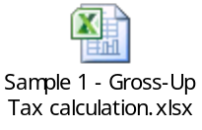
- HI ER Contribution calculated which include Employee contribution. Cargill need to maintain employee contract salary in WT9CON in IT0014 and also IT9521 to be set up with Flag “Employer pays employee contribution”
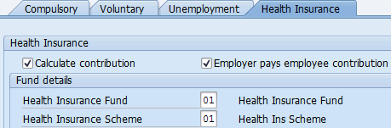

Payslip will looks as below:
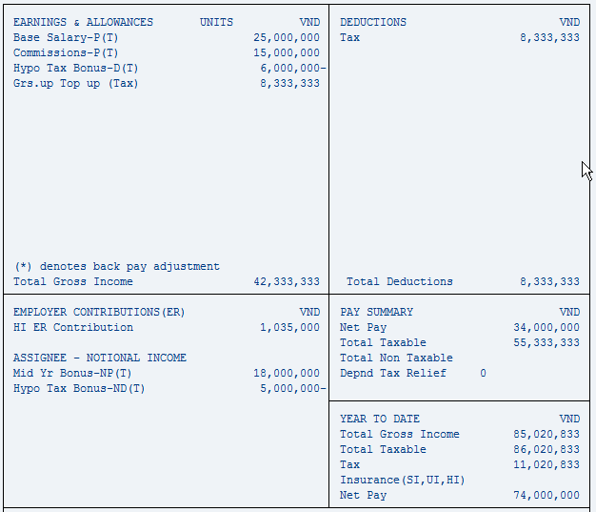

Note: Goss-up Top Up Payment and Tax amount is same here.

Example 2 – Payroll Calculation with Non Gross-up non taxable wagetypes only. [Pay + No Gross-up, Deduct]

Payroll Input is as below:-

WT Code | WT Text | Type | Amount
1Z02 | Base Salary-P(NT) | Pay + No Gross-up | 30,000,000
3Z80 | Yr End Tax-P(NT) | Pay + No Gross-up | 20,000,000
4Z02 | Hypo Tax Bonus-D(NT) | Deduct | -12,000,000

- Gross Pay = 38,000,000 (WT 10Z2 + 3Z80 + 4Z02). This amount will be paid to employee.

- No tax will be calculated on above wagetypes.

- SI contribution can be calculated for these set of employees. Cargill needs to maintain IT9521 and WT9CON in IT0014 as other local employees. Also we have the option to flag on/off employer pay employees SI contribution.

Payroll Input is as below:-
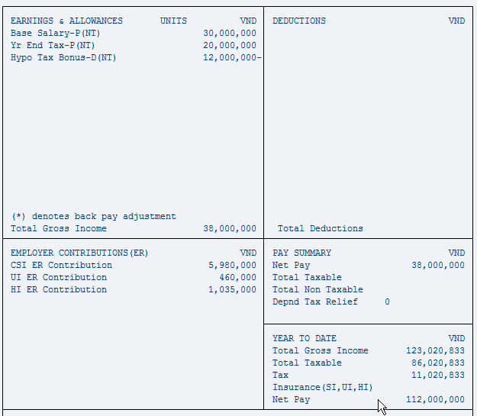

Example 3 - Payroll calculation with all 8 kind of global mobility wagetypes

Payroll Input is as below

WT Code | WT Text | Type | Amount
1Z01 | Base Salary-P(T) | Pay + Gross-up | 25,000,000
3Z01 | Commissions-P(T) | Pay + Gross-up | 10,000,000
3Z08 | Mid Yr Bonus-NP(T) | No Pay + Gross-up | 5,000,000
4Z01 | Hypo Tax Bonus-D(T) | Deduct + (A) | -8,000,000
3Z80 | Yr End Tax-P(NT) | Pay + No Gross-up | 15,000,000
4Z02 | Hypo Tax Bonus-D(NT) | Deduct | -2,000,000
3Z17 | Cash Perf Opt-NP(NT) | No Pay + No Gross-up | 12,000,000
4Z03 | Hypo Tax Bonus-ND(T) | No Deduct + (A) | -4,000,000
4Z04 | Hypo Tax Bonus-ND(NT) | No Deduct | -3,000,000

1. Gross Pay = 40,000,000 (WT 10Z1 + 3Z01 + 4Z01 + 3Z80 + 4Z02). This amount will be paid to employee.
2. Gross-up Taxable income = 28,000,000 (WT 10Z1 + 3Z01 + 3Z08 + 4Z01 + 4Z03). Gross-up Tax will be calculated on this payments. Tax on this will be borne by employer. . Please refer attached file to verify how Gross-up tax is calculated by system.

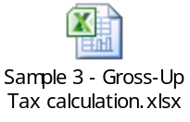
3. Wagetypes not considered for Gross-up Income / local Taxable income = (WT 3Z80 + 4Z02 + WT3Z17+ WT 4Z04).
4. HI ER contribution calculated which include employee contribution. Cargill need maintain employee contract salary in WT9CON in IT0014 and also IT9521 to be set up with Flag “Employer pays employee contribution”
Payslip will looks as below

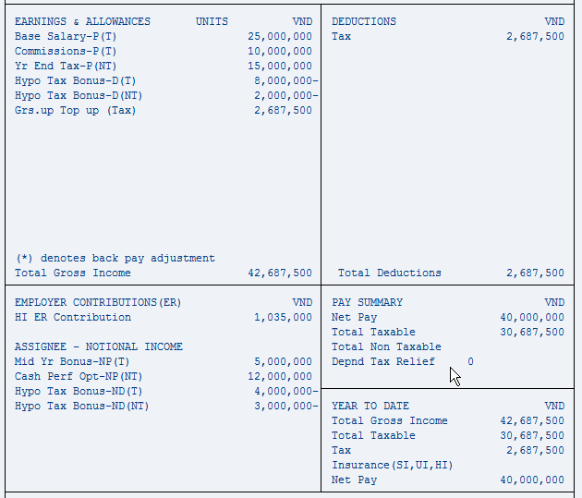

Note: No Difference in Gross up Top UP Vs. Tax,. Tax calculated only on Gross-up wagetypes.

Example 4 - Employee is getting paid with combination of Pay-Gross-up, Pay-No Gross Up and Local wagetypes code.

Payroll Inputs are as below
WT Code | WT Text | Type | Amount
1Z01 | Base Salary-P(T) | Pay + Gross-up | 25,000,000
3Z01 | Commissions-P(T) | Pay + Gross-up | 15,000,000
3Z08 | Mid Yr Bonus-NP(T) | No Pay + Gross-up | 18,000,000
4Z01 | Hypo Tax Bonus-D(T) | Deduct + (A) | -6,000,000
4Z03 | Hypo Tax Bonus-ND(T) | No Deduct + (A) | -5,000,000
3Z80 | Yr End Tax-P(NT) | Pay + No Gross-up | 20,000,000
4Z02 | Hypo Tax Bonus-D(NT) | Deduct | -12,000,000
3655 | Mid Year Perf. Bonus | Pay + Taxable | 22,000,000
3320 | Recognition Award | Pay + Taxable | 4,000,000

Gross Pay = 68,000,000 [WT 10Z1 + 3Z01+ 4Z01 + 3Z80 + 4Z02 + 3655 + 332-]
Gross-up Income = 47,000,000 [WT 10Z1 + 3Z01 + 3Z08 + 4Z01 + 4Z03]
Non-taxable income = 8,000,000 [WT 3Z80 + 4Z02]
Local Taxable Income = 26,000,000 [WT 3655 + 332-]

Tax will be calculated for above input as per attached file. Please verify

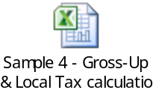

Payslip will looks as below
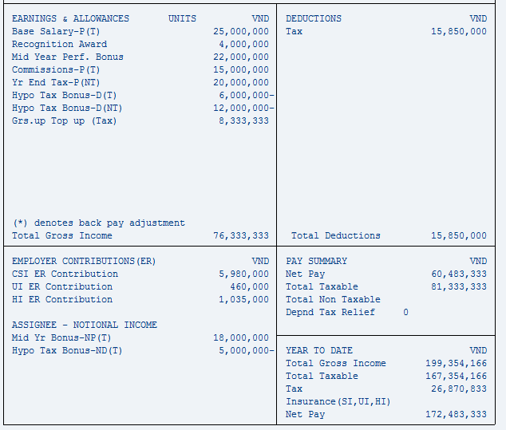
Note: Difference of Tax in deduction window minus Grs. Up Tax Up (Tax) in payment window is the actual tax amount go out from employee pocket.

Goods & Service – Special rule

There is a special rule for Home G&S which is a deduction and Host G&S which is a positive amount. When home G&S exceeds Host G&S, the additional deduction cannot be taken against other income i.e. the deduction has to be limited to the Host G&S.

To meet the above requirement, below wagetype will paired and compared and difference will be generated automatically in a separate wagetypes if deduction amount is more than payment amount.

Wage Type # | Wage Type Text | Valuation | Wage Type # | Wage Type Text | Valuation
3Z34 | Goods & Serv-P(T) | Pay + Gross-up | 4Z31 | Goods & Serv-ND(T) | No Deduct + Gross-up

Sample 1:-

Payroll Input is as below for Gross-up Wagetypes.

Wage Type # | Wage type Text | Valuation | Amount
4Z31 | Goods & Serv-ND(T) | No Deduct + Gross-up | -26,000,000
3Z34 | Goods & Serv-P(T) | Pay + Gross-up | 25,000,000

For above input, a below new wagetype will be automatically generated and displayed in payslip.
Wage Type # | Wage Type Text | Valuation | Amount
3Z90 | Goods & Serv-NP(T) Off Set | No Pay + Gross-up | 1000000

Same as above another WT3Z98 Goods & Serv-NP (T) has been created in system. If Cargill input this wagetype instead of 3Z34, WT3Z90 Goods & Serv-NP (T) will be generated with same rule of 3Z34.

Car Expenses

Only the personal portion is taxable hence car expenses WT’s will be configured with Number and Amount field is mandatory input. Cargill needs to load Car Expenses in amount field and Personal % in number field. Input screen will looks as below

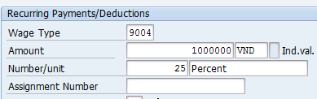

For above input, only 250000 will be applicable for taxation.

Sample Calculation

Create a new wagetype to store taxable and non-taxable portion of the fuel allowance. The solution works as below

1. You will continue to input Fuel Allow in single wagetype WT3Z89 with amount and personal %.
2. ADP split the amount into two wagetype and display in payslip. WT3Z89 will hold taxable portion and WT3Z97 will hold non-taxable Portion.

Example: WT3Z89 input with 2,000,000 and Percentage is 25. The result in payslip will be WT3Z89 = 500,000 and WT3Z97 = 1,500,000.

Below WT’s will be configured for Car Expenses.

WT | Text | WT | Text
3Z59 | Auto Lease-NP(T) | 3Z60 | Auto Lease-NP(NT)
3Z83 | Car Driver-NP(T) | 3Z96 | Car Driver-NP(NT)
3Z89 | Fuel Allow-NP(T) | 3Z97 | Fuel Allow-NP(NT)

Housing– Taxable

Below two wagetypes are created in system to manage Housing taxable income determination.

Wage Type # | Wage Type Text
3Z03 | Housing Allow-NP(T)
3ZA1 | Housing Allow-NP(NT)

Cargill continue to input Housing Allowance in WT3Z03.

System will compare this input amount with 15% taxable income or actual and arrive Taxable housing and store on this wagetype.
Non-Taxable portion of Housing will be stored in WT3ZA1 Housing Allow-NP(NT). This is an auto generated wagetype.

Please see a sample calculation below.
Calculation step for housing will be as below

- Sum up all Gross-up Tax wagetypes and find the gross up tax amount on this. Exclude WT4Z27 and 4Z55 from this calculation.
- Add Local taxable income into sum of Gross-up Tax wagetypes + Gross-up Tax
- Find 15% of this amount and compare with WT3ZA1 and whichever is less will be WT3Z03 Housing taxable.
- Final Value of WT3ZA1 will be WT3ZA1 input amount minus WT3Z03

Housing input in WT3Z03 was 7,000,000
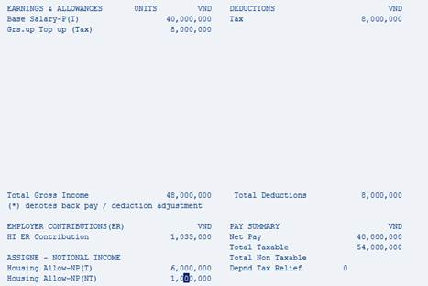

When Calculating 15% of taxable income to deteremine taxable housing amount, below home country SI wagetypes will not be considered.

4Z27 SoSec Hypo Tax-ND(T)
4Z55 Med/Den EE Cont-ND(T)

Monthly Tax calculation method and Year End Tax finalization.

In Globalview, Employee tax is calculated based on the data set up in IT9520. Different tax category can be set up for an employees and system will calculate gross-up tax and local tax according to the set up in this infotype. Example 20% Rate, 10% rate, Progressive Tax Rate etc. Pleaser refer Configuration workbook Tab “Tax” to see the list of combination can be maintained in system.

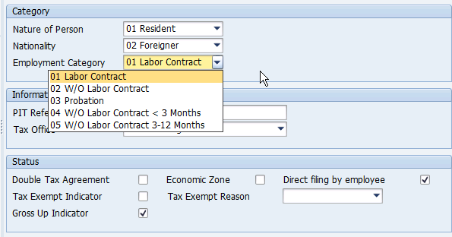

ADP will be calculating the monthly Gross-up tax and Monthly employee tax as shown above sample calculation. However for Inbound and Outbound employees will be excluded from Tax finalization in every January . Cargill can do the tax finalization for these group of employees with EY after considering all inbound and outbound gross-up and non-gross-up taxable income and during this tax finalization calculation if any tax amount to be deducted from employee or refunded to employee, Cargill can use WT7712- Tax Finalization. ADP will provide YTD reports for inbound and outbound employees after every December payroll which shows YTD value for each wagetypes processed from January to December.

When setting up IT950, “Gross Up indicator” and “Direct Filing by employee” should be flagged for Inbound and outbound employees and this flag should be off for local employees.

Output for Inbound and Outbound Employees.

Payroll register, Pay History Report, payslip will be able to generate separately for Inbound and outbound employees and Global Mobility Team can utilize these reports for reconciliation. Also Globalview system display access will be given to global mobility team members with restriction to access only Inpat and Expat employees and Cargill Mobility team will be able to generate the reports anytime from Globalview system as and when required.

Cost Centre Structure
Cargill Vietnam cost center structure will be same as the cost center structure created in Cargill Finance system.

[Vy: There are 2 cases that we need to split the cost into 2or 3 cost centers for all infotype but not split at 1 infotype

Ex:
Cost split in 766009 and 765009 for base salary, bonuses, … but for social contribution, we put whole cost for 765009.]

[Sajith: Yes: We can split cost for salary and bonuses (based on IT0027) into multiple cost center and SI can be reported under employee master cost center maintained in IT0001

.

Configuration Definitions

Company Code Structure
In GlobalView terminology a Company Code represents each legal entity for which Balance Sheets and P&L statements are produced.
The following Company Codes will be created in the system:

Co Code | Company Name | Abbreviation
VN10 | Cargill Vietnam LTD | CVL / 1237
VN20 | Provimi Vietnam LTD | CPN / 1244

Enterprise Structure (Branch Structure)
The Enterprise structure refers to the company’s physical branch structure. It structure controls elements in the system such as Public Holiday groupings, applicable work schedules, wage type groupings, absence/ leave groupings, tax, social insurance etc.

Cargill uses personnel area as Business Unit and Personnel Subarea as site location as defined in OMPA system. GV will follow the same structure for Cargill Vietnam.

Co Code | P. Area | P. Area Text | Psub Area | Psub Area Text
VN10 | ;104 | Functions (Other) | VN07 | Hanoi
 |  |  | VN08 | Ho Chi Minh
 |  |  | VN09 | Hung Yen
 | ;199 | Business Services (CBS) | VN07 | Hanoi
 |  |  | VN08 | Ho Chi Minh
 |  |  | VN09 | Hung Yen
 |  |  | VN01 | Bien Hoa
 |  |  | VN02 | Binh Dinh
 |  |  | VN03 | Can Tho
 |  |  | VN10 | Long An
 | ;198 | Finance | VN07 | Hanoi
 |  |  | VN08 | Ho Chi Minh
 |  |  | VN09 | Hung Yen
 |  |  | VN01 | Bien Hoa
 |  |  | VN02 | Binh Dinh
 |  |  | VN03 | Can Tho
 |  |  | VN10 | Long An
 | ;197 | Strategic Sourcing & Procurmnt | VN07 | Hanoi
 |  |  | VN08 | Ho Chi Minh
 |  |  | VN09 | Hung Yen
 |  |  | VN01 | Bien Hoa
 |  |  | VN02 | Binh Dinh
 |  |  | VN03 | Can Tho
 |  |  | VN10 | Long An
 | ;196 | Global Information Technology | VN07 | Hanoi
 |  |  | VN08 | Ho Chi Minh
 |  |  | VN09 | Hung Yen
 |  |  | VN01 | Bien Hoa
 |  |  | VN02 | Binh Dinh
 |  |  | VN03 | Can Tho
 |  |  | VN10 | Long An
 | ;195 | Transportation & Logistics | VN07 | Hanoi
 |  |  | VN08 | Ho Chi Minh
 |  |  | VN09 | Hung Yen
 |  |  | VN01 | Bien Hoa
 |  |  | VN02 | Binh Dinh
 |  |  | VN03 | Can Tho
 |  |  | VN10 | Long An
 | ;194 | Global Security | VN07 | Hanoi
 |  |  | VN08 | Ho Chi Minh
 |  |  | VN09 | Hung Yen
 |  |  | VN01 | Bien Hoa
 |  |  | VN02 | Binh Dinh
 |  |  | VN03 | Can Tho
 |  |  | VN10 | Long An
 | ;193 | Corporate Aircraft | VN07 | Hanoi
 |  |  | VN08 | Ho Chi Minh
 |  |  | VN09 | Hung Yen
 |  |  | VN01 | Bien Hoa
 |  |  | VN02 | Binh Dinh
 |  |  | VN03 | Can Tho
 |  |  | VN10 | Long An
 | ;192 | Human Resources | VN07 | Hanoi
 |  |  | VN08 | Ho Chi Minh
 |  |  | VN09 | Hung Yen
 |  |  | VN01 | Bien Hoa
 |  |  | VN02 | Binh Dinh
 |  |  | VN03 | Can Tho
 |  |  | VN10 | Long An
 | ;191 | Corporate Affairs | VN07 | Hanoi
 |  |  | VN08 | Ho Chi Minh
 |  |  | VN09 | Hung Yen
 |  |  | VN01 | Bien Hoa
 |  |  | VN02 | Binh Dinh
 |  |  | VN03 | Can Tho
 |  |  | VN10 | Long An
 | ;190 | Law | VN07 | Hanoi
 |  |  | VN08 | Ho Chi Minh
 |  |  | VN09 | Hung Yen
 |  |  | VN01 | Bien Hoa
 |  |  | VN02 | Binh Dinh
 |  |  | VN03 | Can Tho
 |  |  | VN10 | Long An
 | ;189 | Corporate EHS | VN07 | Hanoi
 |  |  | VN08 | Ho Chi Minh
 |  |  | VN09 | Hung Yen
 |  |  | VN01 | Bien Hoa
 |  |  | VN02 | Binh Dinh
 |  |  | VN03 | Can Tho
 |  |  | VN10 | Long An
 | ;188 | Plant Operations | VN07 | Hanoi
 |  |  | VN08 | Ho Chi Minh
 |  |  | VN09 | Hung Yen
 |  |  | VN01 | Bien Hoa
 |  |  | VN02 | Binh Dinh
 |  |  | VN03 | Can Tho
 |  |  | VN10 | Long An
 | ;187 | Corporate FSQR | VN07 | Hanoi
 |  |  | VN08 | Ho Chi Minh
 |  |  | VN09 | Hung Yen
 |  |  | VN01 | Bien Hoa
 |  |  | VN02 | Binh Dinh
 |  |  | VN03 | Can Tho
 |  |  | VN10 | Long An
 | ;186 | Research & Development | VN07 | Hanoi
 |  |  | VN08 | Ho Chi Minh
 |  |  | VN09 | Hung Yen
 |  |  | VN01 | Bien Hoa
 |  |  | VN02 | Binh Dinh
 |  |  | VN03 | Can Tho
 |  |  | VN10 | Long An
 | ;105 | Cocoa & Chocolate | VN04 | Daklak
 |  |  | VN08 | Ho Chi Minh
 | ;106 | Feed & Nutrition | VN01 | Bien Hoa
 |  |  | VN02 | Binh Dinh
 |  |  | VN03 | Can Tho
 |  |  | VN04 | Daklak
 |  |  | VN05 | Dong Thap
 |  |  | VN06 | Ha Nam
 |  |  | VN08 | Ho Chi Minh
 |  |  | VN09 | Hung Yen
 |  |  | VN10 | Long An
 |  |  | VN11 | Tien Giang
 |  |  | VN12 | Vinh
 |  |  | VN13 | Ben Cat
 |  |  | VN14 | Bac Giang
 | ;107 | Grain & Oilseed Asia | VN07 | Hanoi
 |  |  | VN08 | Ho Chi Minh
 |  |  | VN15 | Vung Tau
 | ;111 | Corn Milling | VN08 | Ho Chi Minh
 | ;112 | Metals Supply Chain | VN08 | Ho Chi Minh
 | ;113 | Texturizing Solutions | VN08 | Ho Chi Minh
VN20 | ;208 | Premix & Nutrition | VN01 | Bien Hoa
 |  |  | VN02 | Binh Dinh
 |  |  | VN03 | Can Tho
 |  |  | VN04 | Daklak
 |  |  | VN05 | Dong Thap
 |  |  | VN06 | Ha Nam
 |  |  | VN07 | Hanoi
 |  |  | VN08 | Ho Chi Minh
 |  |  | VN09 | Hung Yen
 |  |  | VN10 | Long An
 |  |  | VN11 | Tien Giang

Please refer Configuration Workbook Tab Enterprise Structure for details.

Employee Group Structure (Employment Terms)
The Employee Group (‘EE Group’) Structure represents categories of employment within the company – e.g. Permanent Officers/ Factory Hourly worker/Part time, etc. The Employee Subgroup is used to create further sub-divisions within Employee Groups.
For Cargill Vietnam, the following Employee Groups will be created in the system:

EE Group | EE Group Text | EE Sub Group | EE Subgroup Text | Country Assignment | Cargill OMPA Code
1 | Perm. / Active - FT | ;L | Salaried | VN | 1 Regular
3 | Temporary - FT | ;L | Salaried | VN | 3 Fixed Term/Temp
C | Casual | ;L | Salaried | VN | C Seasnl/OnCall/Casual
I | Inpats | ;L | Salaried | VN | 6 Assignee Inbound
X | Expats | ;L | Salaried | VN | 5 Assignee Outbound

Please refer Configuration Workbook Tab Employee Group structure for details.

Pay Frequency
‘Pay Frequency’ in the Payroll Area describes both when an employee will be paid and pay-period start and end date.

Payroll Area | Payroll Area Text | Pay Date(s) | Frequency | Accounting Period Start Date | Accounting Period End Date
;M | VN - Monthly | 28th of the Month | Monthly | 1st of the month | Last day of the month
;L | VN - YTD Monthly | NA | Monthly | 1st of the month | Last day of the month

If 28th of the month is Off Day or Public holiday, pay date will be moved to previous working day.
Refer to the Configuration Worksheet for details of available payroll area types.

Groupings [PSG & ESG]
Groupings are used in GlobalView to classify groups of employees with similar characteristics and may be used to configure both data input and payroll calculations based on that input. Every employee will be in both a PS Group and ES Group. Accurate classification of all employees in terms of both Groupings will ensure that wage types are correctly aligned with company requirements and employee entitlements.

Personnel Sub-area Grouping [PSG]:
This describes division of personnel sub-areas into groups to which the same
Attendance and Absence types apply.
- Daily work schedules, period work schedules, and break schedules
- Work Schedule rules
- Time quota types
- (In Time recording) time types, time transfer specifications, access control groups, and error descriptions are defined.

Employee Subgroup Grouping [ESG]:
Employees are grouped in payroll subgroups for the following purposes:
- Work schedule
- Personnel calculation rules
- Primary wage types
- Collective agreement rules
- Time quota types
- Account determination
Please refer to the Blueprint Configuration Worksheet, Groupings Tab, for details.

Payscale Structure
The payscale structure classifies pay-grade information within the system.
Payscale Type
General Management, Corporate Affairs, Legal etc.

Payscale Area
Salaried
ESG CAP
Indicates whether the employee is hourly (1) or salaried (3) worker. Used for calculation.
Payscale Group
Cargill Vietnam store Grade information on this field

Payscale Level
Default value for Cargill Vietnam on this field will be 01

Wagetype
The wagetypes that will default in IT0008 according the Payscale Type/ Area / Group/ Level combination.
Amount
For the wagetype amount will be loaded by Cargill thru G2 interface file or thru SSL.,
Payscale Type | Text | Payscale Area | Text | Payscale Group | Payscale Level
01 | Cargill Vietnam | 01 | Salaried | ADV | 01
 |  |  |  | ASSCPROF | 01
 |  |  |  | ASSCSUPP | 01
 |  |  |  | EXECUTIV | 01
 |  |  |  | MGRI | 01
 |  |  |  | MGRII | 01
 |  |  |  | PROF | 01
 |  |  |  | SRADV | 01
 |  |  |  | SRMGRI | 01
 |  |  |  | SRMGRII | 01
 |  |  |  | SRPROF | 01
 |  |  |  | SRSUPP | 01
 |  |  |  | SUPPORT | 01
 |  |  |  | SUPVI | 01
 |  |  |  | SUPVII | 01
 |  |  |  | UNBANDED | 01

Please refer to the Blueprint Configuration Worksheet, Pay Scale Structure Tab, for details.

Rates of Pay
Rates of Pay refer to any rate-based calculation within the system. These are typically calculations such as overtime and leave calculations.

Below 3 Rate wagetype will be configured for Cargill Vietnam in GV. In Rates of Pay tab of the configuration workbook, we only define rates calculation and this rate WT’s will be connected to a payment wagetype in Payment Tab.

ESG PCR | Hourly Rate (OT) | Daily Rate (Leave Encasement ) | Daily Rate (Sick Leave)
3 | /001 | /002 | /003

Hourly Rate (/001) – For Overtime

Salaried employees
Hourly rate is to be calculated using the period salary (WT1000)
= (SUM (1000) / 22 Days) / 8 Hours

For example:
Monthly employee with period salary is 25,000,000 VND
Hourly Rate (/001) is (25,000,000 / 22 ) / 8 = 142,045 VND
Here let say an employee worked Normal Day OT of 2 hours which is paid by 150%. The Overtime Payout calculation will be Hourly rate (142,045 VND) * 2 Hours * 150% = 426,135 VND

Daily Rate (/002) – For Unused Annual Leave

Salaried employees
Daily rate is to be calculated using the period salary (WT1000)

= SUM(1100) / 22 Days Constant

For example:
Monthly employee with period salary is 25,000,000 VND
Daily Rate (/002) is (25,000,000 / 22) = 1,136,364 VND

Here let say an employee has 4 days unused annual leave during his termination payroll. Unused leave Payout calculation will be Daily rate (1,136,364 VND) * 4 days = 4,545,456 VND

Daily Rate (/003) – For Sick Leave

Salaried employees
Daily rate is to be calculated using the period salary (WT1000)

= SUM( WT1100) Capped to Minimum wages * 20 / 26 Days Constant

Minimum wages as per statutory in current year is 23,000,000

For example:
Monthly employee with period salary is 25,000,000 VND
Daily Rate (/003) will be 23,000,000 / 26 = 884,615 VND

75 % or 100% of this rate will be paid to employee during sick leave.

Please refer to the Blueprint Configuration Worksheet, Rates of Pay Tab, for details.

Prorating Rules
GlobalView allows payments/deductions to be automatically re-calculated by a preset formula if required: for example, in the event of New Hire, Termination, Unpaid Leave, Organizational Assignment Change, Change to Basic Pay or Work Schedule. This method of pro rata calculating actual payment is referred to as ‘factoring’. The factoring method is more accurate than the usual rate- based reduction calculation, which calculates a rate (such as daily rate), multiplies this by the number of days worked and then reduces payments on this basis of calculation. Factoring instead multiplies an amount by a ratio, such as the number of days that be paid / the number of days if the employee worked the full period.

A summary of pro-rating factors (rules) is as follows; details are in the Config Worksheet
Factor 1 | Working Days (/801)

Proration Rule (factor) 1:
Client requires Salary be pro-rata by working days, ie. no. of days worked / no. of working days in the period
For example:
Monthly new hire employee, hired mid-month on 13th May 2015, with Basic Salary 25,000,000
13 days worked, 21 total working days in the month of May 2015 (As per Monday to Friday work pattern)
Factor (/801) = 13 / 21 = 0.6190476
Pro-rata Basic Salary for May = 25,000,000 * 0.6190476 = 15,476,190 VND

In other way 25,000,000 / 21 * 13 = 15,476,190 VND

Unpaid Leave
For example:
Monthly new hire employee, hired mid-month on 13th May 2015, with Basic Salary 25,000,000. 2 days Unpaid leave taken during May 2015.
11 days worked, 21 total working days in the month of May 2015 (As per Monday to Friday work pattern)
Factor (/801) = 11 / 21 = 0.5238095
Pro-rata Basic Salary for May = 25,000,000 * 0.5238095 = 13,095,238VND

In Other way 25,000,000 / 21 * 11 = 13,095,238VND

Please refer to the Blueprint Configuration Worksheet, Prorating or Factoring Tab, for details.

Payments
The Payments Tab documents all the payments that will be made to employees through the system. The following is a brief description of the columns that will directly affect payroll:
ESG & PSG
These determine the ability to enter a wage type into the system against an employee –refer to Groupings, above.
Basic Infotypes IT0008, IT0014, IT0015, IT0267, IT2010, IT2001
These columns indicate the basic infotypes into which payment codes will be entered.
Each infotype is designed for a specific function, as follows:
IT0008 Basic Pay:
Any payment codes that are considered part of basic salary or affect calculations such as overtime/ leave calculations. These payment codes are paid each pay period and usually do not change often. e.g. Monthly Basic Salary/ Packaged Bonus.
IT0014 Recurring Payments/Deductions
Any payment codes that are paid on a regular/ periodic basis – e.g. every month, or every 2nd month. These payment codes can be designed to reduce based on new hire dates/ termination dates and unpaid leave, e.g. Car Allowance.
IT0015 Additional Payments:
Any payment codes that are paid on an ad-hoc/ once off basis, in the regular pay-run – e.g. once-off bonus/ performance bonus.
IT0267 Additional Off-cycle Payments
As above (IT0015), but made outside of the regular pay-run (off cycle run) – e.g. expense reimbursements, bonus payment etc.
IT2010 Employee Remuneration info
Any time related payments such as overtime payment codes, meal allowance, shift allowance.
IT2001 Absences
Any leave type – e.g. Annual Leave, Sick Leave etc.
Amount/ Number Unit
Indicates if the wagetype will be entered in as an amount, or as a number/ unit calculation. E.g. A commission/ bonus payment is usually entered in as an amount, but overtime is entered as number of hours multiplied by an hourly rate. Refer to the Rates of Pay tab in the configuration worksheet for details on how the leave rate and overtime hourly rate will be calculated.
Prorating Rule
Indicates the prorating rule that will be used to reduce the amount paid of the wagetype, based on new hire date, termination date and unpaid leave. Refer to ‘Prorating or Factoring’ worksheet for descriptions.
Specific Wage-type Settings
The remaining columns on the Payment spreadsheet indicate details such as if the wagetype will actually be paid to the EE (Total Gross), if it is taxable/ non taxable, where it will appear on the payslip etc, and any special rules that are to be noted for this payment code.
Please refer to the Blueprint Configuration Worksheet, Payments Tab, for details.
Auto Calculation - Specific wagetypes - Payments
Cargill Vietnam Payment Wagetypes which are attached to certain set of business rules and required automation in system are listed below with sample calculation. Kindly note that all payment wagetypes are not listed below since these WT’s input method is direct amount or it hold simple calculation. You can refer these details on Payment tab of the configuration workbook.

WT3340 - Mobile Phone Subsidy
As per the business rule, this payment to be made to employee only once in two years. Cargill will provide direct input amount in IT0015 for this wagetype however ADP will set up a variant under wagetype reporter for HR to check whether this payment is made to employees in last two years or not. In case this payment is already made to employee in last two years, then HR should not input this wagetype in GV system.
The report generation screen will looks as below. You need to change the period start date and end date based on your payroll month to do this validation.
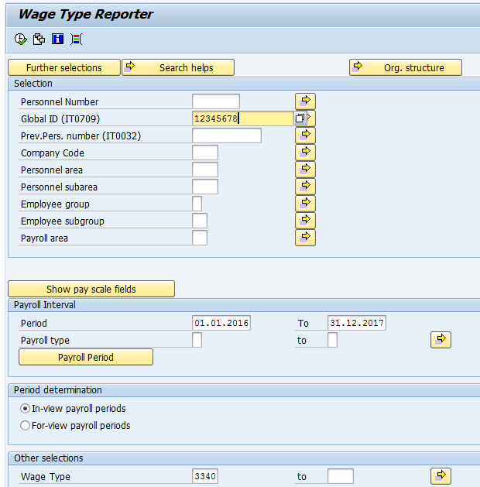

- WT 2508 Sick Leave (SI) & WT 2509 Sick Leave - Maternity (SI)
There are two types of absence created in system as below and input for this calculation will come from ESS once manager approved employee sick leave request. Cargill HR can also load absence details in IT2001 in case employee didn’t submit the leave in ESS.
Leave Type | Leave Type Text | Payment Code
1100 | Sick Leave (SI) | 2508
1150 | Sick Leave - Maternity (SI) | 2509

WT2508 Sick Leave (SI) Calculation will be as below.
Basic Salary / 26 * Number of Days Sick Leave * 75%. Here basic salary is capped to minimum wages * 20. This amount will be reduced from Basic salary.
Example: An employee Basic salary is 25,000,000 and employee taken 4 days sick leave in the month.
Daily rate (/003) for sick leave will be 23,000,000 / 26 = 884,615
Sick Leave = 884,615 * 4 days * 75% = 2,653,845 VND. This amount will be reduced from Basic salary. Payslip will looks as below.
Payment | Amount
Basic Salary | 22,346,155
Sick Leave (SI) | 2,653,845
Total Gross Payment | 25,000,000

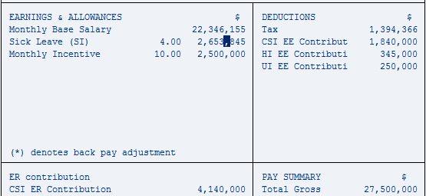

The Sick Leave (SI) amount is not taxable component for employees.

WT2509 Sick Leave - Maternity (SI) Calculation will be as below
Basic Salary / 26 * Number of Days Sick Leave * 100%. Here basic salary is capped to minimum wages * 20. This amount will be reduced from Basic salary.
Example: An employee Basic salary is 21,000,000 and employee taken 4 days sick leave maternity in the month.
Daily rate (/003) for sick leave maternity will be 21,000,000 / 26 = 807,692
Sick Leave – Maternity = 807,692 * 4 days * 100% = 3,230,768 VND. This amount will be reduced from Basic salary. Payslip will looks as below
Payment | Amount
Basic Salary | 17,769,232
Sick Leave (SI) | 3,230,768
Total Gross Payment | 21,000,000

The Sick Leave – Maternity (SI) amount is not taxable component for employees.

WT2507 Prenatal Leave (SI) calculation will be as below
Basic Salary / 26 * Number of Days Prenatal Leave * 100%. Here basic salary is capped to minimum wages * 20. This amount will be reduced from Basic salary.
Example: An employee Basic salary is 21,000,000 and employee taken 4 days Prenatal Leave in the month.
Daily rate (/003) for sick leave maternity will be 21,000,000 / 26 = 807,692
Prenatal Leave = 807,692 * 4 days * 100% = 3,230,768 VND. This amount will be reduced from Basic salary. Payslip will looks as below
Payment | Amount
Basic Salary | 17,769,232
Sick Leave (SI) | 3,230,768
Total Gross Payment | 21,000,000

- WT3705 Maternity Leave Allowance (SI) & 3706 Adoption Leave Allowance (SI)
During Maternity leave and Adoption leave period, salary will be unpaid/prorated to employees.
To pay maternity leave allowance, Cargill needs to load number of child on this wagetype in IT0015.
If Cargill load Number = 1 or 2, then calculation will be as below
1 Child - Average last Six month Salary contributed to social insurance * 6 + Minimum Wages * 2
2 Child - Average last Six month Salary contributed to social insurance * 7 + Minimum Wages * 2
Average Salary to be capped to Minimum Wages * 20

Example – Employee last six month average monthly salary is 25,000,000 and Cargill has loaded Number = 1 child for this employee.
Maternity will be 23,000,000 * 6 + 1,150,000 * 2 = 140,300,000 VND
** In year 2015, Common minimum wage is 1, 150,000
To Pay Adoption Leave, Cargill needs to load number of months to be paid in IT0015 in WT3706.
Average last Six month Salary contributed to social insurance * Number of months loaded by Cargill + Minimum Wages * 2
Example: - Employee average salary is 25,000,000 and Cargill loaded Number = 4 on WT3706.
Adoption allowance will be 25,000,000 * 4 + 1,150,000 * 2 = 102,300,000 VND

- Overtimes
As per Vietnam statutory rule, Overtime premium is non-taxable components. Cargill has specific requirement to split and print overtime wagetypes in payslip based on Taxable and non-taxability.

Below table explain the input wagetype and output wagetypes.
Input Wagetype |  | Taxable OT |  | Non Taxable OT
2010 | Normal Day OT | 2TX0 | Normal Day OT - Taxable | 2NT0 | Normal Day OT-No Tax
2111 | Day Off OT | 2TX1 | Day Off OT - Taxable | 2NT1 | Day Off OT - No Tax
2112 | Holiday | 2TX2 | Holiday - Taxable | 2NT2 | Holiday OT - No Tax
2113 | Night Shift Normal Day OT | 2TX3 | OT/Night/Normal/Taxable | 2NT3 | OT/Night/Normal/No Tax
2114 | Night Shift Day Off OT | 2TX4 | OT/Night/Day Off/Taxable | 2NT4 | OT/Night/Day Off/No Tax
2115 | Night shift Holiday | 2TX5 | OT/Night/Holiday/Taxable | 2NT5 | OT/Night/Holiday/ No Tax

Sample Calculation of Taxable and Non Taxable Over time Split
Normal Day OT – This OT is paid @ 150 %.
Cargill input Normal OT Hours in WT2010 as 2 hours and Basic salary is 25,000,000
Hourly rate (/001) = ((25,000,000 / 22) / 8) = 142,046
Taxable Normal Day OT = 142,046 * 2 Hours * 100% = 284,092 VND
Non Taxable Normal Day OT = 142,046 * 2 Hours * 50% = 142,046 VND

Payslip Payment window will looks as below with Normal Day OT split
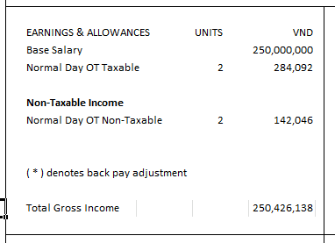

The same above mentioned calculation method will follow for all the OT wagetypes. Please refer configuration workbook Payment Tab for calculation rules.

- WT 5000 - Severance Pay
1. This payment needs to be triggered automatically in employee’s last payroll if employee joined on or before 1st Jan 2009.
2. Severance Pay amount is Last Six Month Average Salary which include employee last month payoll * Service Year * 0.5
3. Service year is Hire date to 31st Dec 2008 due to employees are started contributing to the Unemployment Insurance from 1st Jan 2009.
4. If WT5005 Redundancy Pay is paid, this wagetype should not be calculated.
5. If employees terminated due to Violation of company policy, then Cargill needs to send Action reason as '03 - Dismissal without Notice' and for these set of employees, system will not calculate Severance Pay automatically.
5. Since service period for severance pay is already known and its freeze, during initial load cut over period, Cargill needs to calculate Service period for all applicable employees and load into WT5001 in IT2010
6. During termination payroll, ADP will process severance pay only for the employees to whom Cargill loaded Service year during Initial Go Live load.
7. In case if Cargill Input amount on this wagetype, system will ignore auto calculated amount and consider input amount for Severance Pay.

Sample: Employee terminated on 10th July 2016 and Service year loaded in WT5001 during go live month is 8.5 years. Basic salary for last 6 month is as below.
Month | Basic Salary
Jan-16 | 25,000,000
Feb-16 | 25,000,000
Mar-16 | 25,000,000
Apr-16 | 25,000,000
May-16 | 28,000,000
Jun-16 | 28,000,000
Total | 156,000,000
Average | 26,000,000

Severance Pay amount in July 2016 payroll will be 26,000,000 * 8.5 * 0.5 = 110,500,000 VND
- 5060 - Term Unused Leave
- This payment will be triggered for every employee during their last payroll if they have annual leave positive balance/negative balance.
- Formula for Term Unused leave is Basic salary / 22 * Annual Leave balances.
- Daily rate /002 will be used for calculating this payment. Daily Rate /002 = Basic Salary /22.
- Term Unused Leave will be paid only for the employees who has passed the probation.
Sample: An employee basic salary is 25,000,000 and his unused annual leave balance on termination month is 10 days.
Annual Leave Encashment amount will be = 25,000,000 / 22 * 10 = 11,363,636 VND

- Incentive programme
Cargill Vietnam has various bonus calculations and each bonus calculation is attached to specific business rules. Below are the wagetypes related to incentive programme will be configured in GV.
There are incentive wagetypes which will be calculated based on whether employees in Commission based or Non-Commission based. This identification will be stored in IT0001-Contract type.
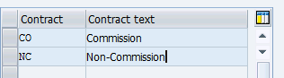

a). WT3645 Monthly Incentive
1. Cargill to load Bonus rate to eligible employees (excluding Under PIP employees) in every month payroll. This bonus is paid for Non Commission-based employees. For PIP employees, either Cargill can exclude WT3645 from the input or input WT3645 along with WT3661 to stop this pay. This calculation based on % input will be triggered only for; 106 Feed & Nutrition EE group 1 employees. This means that even Cargill mistakenly load MI % of a Temporary or other BU employees, system will not process this MI Bonus.

2. Previous Month Bonus is paid in current month hence Bonus amount will be last month Basic Salary * Bonus Rate.
3. If an employee did not work 50% of the Total working days of last month, then bonus will not be paid. Here Working days = Planned working days in a month minus all Paid and Unpaid Leave. Actual Days worked for this validation will be taken only from BU ;106, EE group 1 and Non Commission and this validation control transfer employees calculation.

4. This bonus will be paid to employees irrespective of employee status is whether active or resigned during bonus distribution month. Cargill needs to provide Bonus rate for resigned employees as well and ADP will do the validation whether employee worked 50% of the working day in last month or not and based on this payout amount will be generated.
5. If employee is already terminated in last month but Cargill provided input in current payroll, then ADP will extend Infotype 0003 Run payroll upto field to include the employee in current payroll run.
6. If Cargill load an amount on this wagetype, system will ignore the calculation rule and pay the amount input by Cargill. Please note that If amount is provided, system will not even look at PIP identifier and whatever amount input by Cargill will be paid to employee.
Sample Calculation
Sample 1: Employee April 2015 Salary is 25,000,000 and May 2015 Salary is 28,000,000. Bonus rate loaded by Cargill in May 2015 is 15% and employee has worked full months without any leave in April 2015.
Monthly Incentive amount in May 2015 will be 25,000,000 * 15% = 3750,000 VND
Sample 2 : Employee April 2015 Salary is 25,000,000 and May 2015 Salary is 28,000,000. Bonus rate loaded by Cargill in May 2015 is 15% and employee has taken leave as below in April 2015.
8 Days Annual Leave
5 Days Sick Leave
Total working days in April 2015 are 22 days and 50% of the total working day is 11 days. However employee is only worked 9 days (22 days – 8 Day AL – 5 Day SL) in April 2015 hence no bonus will be paid to employee in May 2015. The same working day validation will be applied for mid hire and resign cases.

b.) WT3650 Quarterly Volume Bonus
1. Cargill to load Bonus rate in the 1st monthly payroll of the next quarter for all eligible employees excluding under PIP employees. i.e. every September, December, March and June. This bonus is paid for Non Commission-based employees. For PIP employees, either Cargill can exclude WT3650 from the input or Input WT3650 along with WT3661 to stop this pay This calculation based on % input will be triggered only for; 106 Feed & Nutrition EE group 1 employees. This means that even Cargill mistakenly load QB % for a Temporary or other BU employees, system will not process this QB Bonus.

2. In current payroll (eg: September) bonus is paid for the last quarter. Hence Bonus amount will be last 3 months average salary (Jun, Jul, Aug) * Bonus Rate. WT1000 Monthly Base salary Unprorated amount will be taken for average salary.
3. If an employee did not work 50% of the total working days in the last 3 months, then bonus will not be paid. Here working days = Planned working days in last 3 month minus all Paid and Unpaid Leave during last 3 months. Actual Days worked for this validation will be taken only from BU ;106, EE group 1 and Non Commission and this validation control transfer employees calculation.
4. Cargill follow Financial Year, June to May for this bonus payout hence the quarter months will be as below.
Quarter 1 - June, July, Aug - For September Bonus, Average and working days to be taken from this quarter.
Quarter 2 - Sep, Oct, Nov - For December Bonus, Average and working days to be taken from this quarter.
Quarter 3 - Dec, Jan, Feb - For March Bonus, Average and working days to be taken from this quarter.
Quarter 4 - Mar, Apr, May -For June Bonus, Average and working days to be taken from this quarter.

5. If Cargill load an amount on this wagetype, system will ignore the calculation rule and pay the amount input by Cargill. Please note that If amount is provided, system will not even look at PIP identifier and whatever amount input by Cargill will be paid to employee.
6. Employee should be active on pay date of the bonus distribution month to get this bonus.
7. Only days and salary worked under Non-commission based will be considered for calculation in case of conversion from Commission based to Non-Commission and vice versa.

Sample 1: Employee March 2015 Salary is 25,000,000, April 2015 Salary is 25,000,000 and May 2015 Salary is 28,000,000. Bonus rate loaded by Cargill in June 2015 is 10% and employee has worked last 3 months without any leave.

Average salary is (25,000,000+25,000,000+28,000,000) / 3 = 26,000,000 VND
Quarterly Volume Bonus = 26,000,000 * 10% = 2,600,000 VND

Sample 2: Employee March 2015 Salary is 25,000,000. April 2015 Salary is 25,000,000 and May 2015 Salary is 28,000,000. Bonus rate loaded by Cargill in June 2015 is 10%. During this period, employee has taken 15 days Annual leave, 15 days Unpaid Leave and 4 days sick leave
Average salary is (25,000,000+25,000,000+28,000,000) / 3 = 26,000,000 VND
Working days in the quarter = 66 days .
50% of working days = 33
Employee actually worked = 32 days (66-34). Since employee did not work 50% of the quarter, no bonus will be paid out to employees.

c.) 3655 Mid Year Performance Bonus

1. This bonus is calculated on every January and calculation period is previous year June to December.
2. This bonus is paid to Cargill Vietnam Limited (VN10) under Personal Area ;106 Feed & Nutrition employees. Only applicable to EE group 1 Perm/Active.
3. Cargill needs to load a notional WT 3661 with value = 1 in amount field to identify PIP employees in every Jan to stop this pay for ineligible employee.
4. If employee joins before or on 1st June - Full one month salary will be paid as bonus.
5. If employee join after 1st June but before 1st Nov - Bonus amount will be Basic salary / Number of months from June to Dec (7) * number of months from Hire date to 31st Dec. (to be commercial rounded)
6. If employee joined after 1st Nov, then employee will not be eligible for bonus.
7. If Cargill load an amount on this wagetype, system will ignore the calculation rule and pay the amount input by Cargill
8. Employee should be active on pay date of the bonus distribution month (January) to get this bonus. Pay date is for Cargill is fixed on 28th of every month. If 28th is Off day, then pay date will be moved to previous working day and if employee active on this adjusted pay date, employee will get the bonus.
9. If an employee moved from other Personal Area to Personal Area :106 Feed & Nutrition during the June to December, only the months worked under personal Area :106 Feed & Nutrition will be considered for Bonus Calculation.
10. If employee worked in Personal area :106 Feed & Nutrition during June to December however employee not with Personal area ;106 Feed & Nutrition during January, in this case system will not trigger the Mid year performance bonus. Cargill can input direct amount on this WT for this type of exceptional cases.
Sample 1
Employee joined 25th June 2015 and Salary is 25,000,000 VND
Total Number of months worked = For June 2015, 6/30 = 0.2 + July to Dec = 6. Hence total days to be paid is 6.2 months
Bonus amount in Jan 2016 = 25,000,000 / 7 * 6.2 = 22,142,857 VND

Sample 2 – Employee joined 1st Feb 2015 Salary is 25,000,000 VND. However employee terminated on 26th Jan 2016 and Pay date is 28th Jan 2016.
No Bonus will be paid to this employee in Jan 2016 payroll since he is not active on Pay date of the bonus distribution month.

d.) WT 3660 Fiscal Year-end Volume Bonus
1. This bonus is calculated on every June and calculation period is previous year June to current year May.
2. This bonus is paid to Cargill Vietnam Limited (VN10) under Personal Area ;106 Feed & Nutrition employees with EE group 1 Perm/ Active ONLY.

However if employee Pay Scale Groups are below listed, then this bonus should not be calculated.
EXECUTIV
MGRI
MGRII
ADV
SRADV
SRMGRI
SRMGRII
3. This bonus will be paid prorata basis for employees who joined during the year. The conditions are as below.
Employees joined on or before 1 June will receive 100% bonus.

Employees joined after 1 June but on/before 1 December will receive 50% bonus.

Employees joined after 1 December but on/before 1 March will receive 25% bonus.

Employees joined after 1 March will not be entitled to this program.

4. Cargill needs to load a notional WT 3661 with value = 1 in amount field to identify PIP employees in every June to stop this pay for ineligible employee.
7. If Cargill load an amount on this wagetype, system will ignore the calculation rule and pay the amount input by Cargill
8. Employee should be active on pay date of the bonus distribution month (June) to get this bonus. Pay date is for Cargill is fixed on 28th of every month. Example: - 28th June 2015 is Sunday, hence pay date for June 2015 will be moved back to 26th June 2015 (previous working day). If an employee last working day is 26th June 2015, we should pay Mid-Year Performance bonus and if last working day is 25th June 2015 or prior, then employee is not eligible for Fiscal Year-End Volume bonus.
9. If an employee moved from other Personal Area to Personal Area ;106 Feed & Nutrition during the June to May, joining date validation based on movement date to ;106 Feed & Nutrition will be considered for Bonus Calculation.
10. If employee worked in Personal area ;106 Feed & Nutrition during June to May however employee not with Personal area ;106 Feed & Nutrition during June, in this case system will not trigger the Fiscal Year-End Volume bonus. Cargill can input direct amount on this WT for this type of exceptional cases.
11. When we go live in Jan 2016, Cargill needs to input WT9660 FY Bouns % in IT2010 for employees joined prior to 1st Jan 2016. Employee Joined from 1st Jan 2016 onwards, system will derive the FY Bonus % automatically. This is one time data entry for Cargill as part of go live data load. This exception is due to ADP system cannot run payroll/time prior to 1st Jan 2016 and derive employees FY Bonus %.

Sample 1 – Employee joined on 3rd June 2015 and salary is 25,000,000.
In June 2016, Bonus amount is 25,000,000 * 50% = 12,500,000.

Sample 2 – Employee joined on 3rd Dec 2015 and salary is 25,000,000.
In June 2016, Bonus amount is 25,000,000 * 25% = 6,250,000.
Sample 3 – Employee joined on 3rd Mar 2016 and salary is 25,000,000.
In June 2016, No Bonus amount will be paid to employee since he joined after 1st March.
Sample 4 - Employee joined on prior to June 2015 and salary is 25,000,000. Employee last working day is 25th June 2016 and adjusted pay date for June 2016 payroll is 26th June 2016
In June 2016, No Bonus amount will be paid to this employee since this employee is not active on pay date.

e.) WT3665 13th Month Salary
1. 13th Month salary earned Period is Jan to Dec and this bonus is paid on every January for previous year. Employee should be active on 31st Dec to eligible for this bonus.
2. All employees from all legal entities under “EE Group 1 – Active” are eligible for this Bonus.
3. Non commission based employees: - Bonus amount will be average base salary from Jul to Dec / 12 * number of months worked.
4. For commission based employees: - Bonus amount will be (Average base salary from Jul to Dec + average commission from Jan to Dec) / 12 *Number of months worked.
5. If an employee has taken unpaid leave (Leave type 3000 & 3100 only), 13th month eligibility month needs to be prorated. Please see example 3.
.Commission amount to be taken from below two wagetypes
Wage Type # | Wage Type Text
3695 | Base Commission
3700 | Grow Commission

- Number of months worked = Prorated month in hiring month + remaining month. Let say an employee joined on 18th Jan 2015, number of months worked will be (14/31) + 11 months = 11.45 months
6. If Cargill load an amount on this wagetype, system will ignore the calculation rule and pay the amount input by Cargill

Sample 1 :- Employee joined on 16th Feb 2015 and Salary is 25,000,000.
Bonus amount in Jan 2016 = 25,000,000 / 12 * 10.46= 21,791,667 VND
Number of Months worked =(13/28)+10 = 10.46
Blue Print – Cargill agree to follow this option | Current practices
= (13/28) + 10 = 10.46 months | = (31 Dec 2015 - 16 Feb 2015) / 30 = 10.6 months

Sample 2: A commission based Employee Joined 10th June 2015 and Salary is 25,000,000 and commission received from June 2015 to Dec 2015 is as below.

Month | Commission
Jun-15 | 1,000,000
Jul-15 | 1,500,000
Aug-15 | 2,000,000
Sep-15 | 2,500,000
Oct-15 | 3,000,000
Nov-15 | 1,000,000
Dec-15 | 7,000,000
Total | 18,000,000
Average last 12 month commission | 18,000,000/ 7 = 2571429

Bonus amount in Jan 2016 = (25,000,000 +2,571,429) / 12 * 6.7 = 15,394,048 VND
Number of months worked = (21/30) + 6 = 6.7 months
Sample 3 : Employee in Non Commission from Jan 2015 to Aug 2015 and employee moved to Commission from Sep 2015. Details of salary received as below:-
Type | Month | Basic Salary | Commission
Non-Commission | Jan-15 | 25,000,000 | 0
Non-Commission | Feb-15 | 25,000,000 | 0
Non-Commission | Mar-15 | 25,000,000 | 0
Non-Commission | Apr-15 | 25,000,000 | 0
Non-Commission | May-15 | 25,000,000 | 0
Non-Commission | Jun-15 | 25,000,000 | 0
Non-Commission | Jul-15 | 25,000,000 | 0
Non-Commission | Aug-15 | 25,000,000 | 0
Commission | Sep-15 | 20,000,000 | 5,000,000 (Commission Support)
Commission | Oct-15 | 20,000,000 | 5,000,000 (Base commission
Commission | Nov-15 | 20,000,000 | 1,000,000(Gross Commission)
Commission | Dec-15 | 20,000,000 | 1,000,0000(Commission Support)
 | Average Salary | Last 6 Month –  130,000,000 / 6 = 21,666,667 | Average Commission –  15,000,000 / 2 = 7,500,000  Note: commission support amount and month is ignored from the average calculation.

Bonus amount in Jan 2016 = (21,666,667)/12 * 12 + (7,500,000) /12 * 4 = 24166667 VND

Sample 3 – Employee has joined prior to Jan 2015 and has taken leave as below
Leave Type | Leave Type Text | Start Date | End Date | Number of Days leave | Remarks
3000 | Unpaid Leave (Short Term) | 20th July 2015 | 28th July 2015 | 7 | Short term leave days counted in Working days basis for 13th Month Salary
3100 | Unpaid Leave(Long Term) | 3rd Aug 2015 | 24th Aug 2015 | 22 | Long Term leave days counted in Calendar Day Basis for 13th Month Salary

Number of months 13th month salary will be paid calculated as below for Jan 2016 Payout.

Month | Number of Month
Jan-15 | 1
Feb-15 | 1
Mar-15 | 1
Apr-15 | 1
May-15 | 1
Jun-15 | 1
Jul-15 | 0.77 (24 Days / 31)
Aug-15 | 0.29 (9 days /31)
Sep-15 | 1
Oct-15 | 1
Nov-15 | 1
Dec-15 | 1
Total | 11.06

For this employee, 11.06 months will be paid for 13th month salary in Jan 2016. Example. Employee Salary is 25,000,000 VND
13th Month pay in Jan 2016 = 25,000,000 / 12 * 11.06 = 23041667 VND

Accrual Wagetypes
- WT9002 13th Month Bonus Accrual
1. This accrual will be calculated every month during Jan to December and for all employees under EE Group 1 - Active in all legal entity.
2. Non commission based employees = Monthly accrual amount will be Base salary /12 * Number of the month worked.
3. For commission based employees = (Monthly base + Average Commission Jan to Dec) / 12 * number of months worked.
Below wagetypes will be considered for commission average calculation
Wage Type # | Wage Type Text
3695 | Base Commission
3700 | Grow Commission

4. Number of months worked = Previous months + current month. Let say an employee joined on 18th Jan 2015. For Feb 2015 accrual, number of months will be (14/31) + 1 = 1.45, for March (14/31) + 1 + 1 = 2.45 months
5. No need to calculate this accrual during employee last payroll since they are not eligible for payout except last working day is 31st Dec cases.
Sample 1: - Non commission based employees joined on 20th Jan 2015 and Basic Salary is 25,000,000
Accrual 13th Month bonus for Jan: 25,000,000 / 12 * .39 = 812,500 VND
[(31st Jan – 20th Jan) / 31] = .39
Accrual 13th Month bonus for Feb: 25,000,000 /12 * 1.39 = 2,895,833 VND and same calculation will follow for subsequent months

Sample 2: Commission based employees joined 10th June 2015 and Salary is 25,000,000 and commission received from June 2015 to Nov 2015 is as below.

Month | Commission
Jun-15 | 1,000,000
Jul-15 | 1,500,000
Aug-15 | 0
Sep-15 | 2,500,000
Oct-15 | 3,000,000
Nov-15 | 1,000,000
Total | 9,000,000
Average | 1,800,000

Accrual amount in Nov 2015 will be (25,000,000 + 1,800,000) / 12 * 5.7 = 12,730,000VND

- WT9004 - Quarterly Bonus Accrual
1. Cargill to load Quarterly Bonus accrual rate on this wagetype. This is an IT0014 recurring wagetypes. Hence the expectation is that Cargill can load the estimated bonus rate start of every quarter month.
2. Average Base salary / 3 * Number of the month in quarter (1 to 3) * Bonus accrual rate. Same as Quarterly Bonus payout, average salary of the quarter will be considered for QB accrual calculation. System also check whether employee worked 50% of working days in this quarter in the last month payroll of the quarter. In case employee did not work 50%, QB accrual will not be generated in last month of the quarter payroll since employee is not going get paid QB in next month payroll.
Sample 1:- Employee Base salary is 25,000,000 and estimated Bonus rate for the Quarter 1 is 10%.
Quarter 1 contains June, July, Aug
Accrual for June = 25,000,000 / 3 * 1 *10% = 833,333 VND
Accrual for July= 25,000,000 / 3 * 2 * 10% = 1,666,667 VND
Accrual for Aug = 25,000,000 / 3 * 3 * 10% = 2,500,000 VND

- 9006 – Mid Year Bonus Accrual
- This bonus is accrued to Cargill Vietnam Limited (VN10) under Personal Area ; 106 Feed & Nutrition employees and only EE group 1 Perm/Active.
- This accrual is generated only from June to December.
- Accrual amount will be Base salary / 7 * Number of the months worked from June to Dec.
- If employee joined after 1st Jun, number of months worked will be prorated for calculation.
- If employee terminated during accrual period, then no need to calculate accrual in employee last payroll.

Sample 1
Employee Joined 25th June 2015 and Salary is 25,000,000 VND
Prorated month of June 2015 = 6 / 30 =.20
Jun 2015 Accrual = 25,000,000 / 7 * .2 = 714286 VND
Jul 2015 Accrual = 25,000,000 / 7 * 1.2 = 4285714 VND
Aug 2015 Accrual = 25,000,000 / 7 * 2.2 = 7857143 VND
Sep 2015 Accrual = 25,000,000 / 7 * 3.2 = 11428571 VND
Oct 2015 Accrual = 25,000,000 / 7 * 4.2 = 15000000 VND
Nov 2015 Accrual = 25,000,000 / 7 * 5.2 = 18571429 VND
Dec 2015 Accrual = 25,000,000 / 7 * 6.2 = 22142857 VND

- WT9008 - Fiscal Year End Bonus Accrual

1. This bonus will be accrued every month June to May only for Cargill Vietnam Limited (VN10)under Personal Area ;106 Feed & Nutrition employees ONLY. However if employee Pay Scale Groups are below listed, then this bonus should not be accrued.
EXECUTIV
MGRI
MGRII
ADV
SRADV
SRMGRI
SRMGRII
- Base salary / 12 * Number of the month (Accrual period is June to May) * % will be the formula for calculating accrual. Percentage will be decided based on employee joining date as below
Employees joined before 1st Jun -> 100% bonus
Employees joined From 1st Jun to 30th Nov -> 50% bonus
Employees joined From 1st Dec to 28th Feb -> 25% bonus
Employees joined after 1st Mar -> 0% bonus

Employees joined on or before 1 June will receive 100% bonus.

Employees joined after 1 June but on/before 1 December will receive 50% bonus.

Employees joined after 1 December but on/before 1 March will receive 25% bonus.

Employees joined after 1 March will not be entitled to this program.

- If employee terminated during accrual period, then no need to calculate accrual in employee last payroll.
Sample 1: An employee Joined on 10th May 2015 and Basic salary is 25,000,000. His accrual will be calculated as below for June 2015 to Aug 2015

Jun 2015 Accrual = 25,000,000 / 12 * 1 * 100% = 2,083,333 VND
Jul 2015 Accrual = 25,000,000 / 12 * 2 * 100% = 4,166,667 VND
Aug 2015 Accrual = 25,000,000 / 12 * 3 * 100% = 6,250,000 VND

Sample 2: An employee Joined on 10th June 2015 and Basic salary is 25,000,000. His accrual will be calculated as below for June 2015 to Aug 2015.

Jun 2015 Accrual = 25,000,000 / 12 * 1 * 50% = 1,041,667 VND
Jul 2015 Accrual = 25,000,000 / 12 * 2 * 50% = 2,083,334 VND
Aug 2015 Accrual = 25,000,000 / 12 * 3 * 50% = 3,125,000 VND

Sample 3: An employee Joined on 10th December 2015 and Basic salary is 25,000,000. His accrual will be calculated as below for Dec 2015 to Feb 2016.

Dec 2015 Accrual = 25,000,000 / 12 * 7 * 25% = 3,645,833 VND
Jan 2016 Accrual = 25,000,000 / 12 * 8 * 25% = 4,166,667 VND
Feb 2016 Accrual = 25,000,000 / 12 * 9 * 25% = 4,687,500 VND
Sample 4: An employee Joined on 3rd^{th} March 201 and Basic salary is 25,000,000.
No accrual will be calculated for this employee during this accrual period since employee joined after 2nd March.

- WT9010 Severance Pay Accrual
1. Severance Pay Accrual will be Last 6 month average Base salary include current month* Service Period * .5.
2. During cut over, Cargill needs to load Service period for Severance pay in WT5001 for all employees joined prior to 1st Jan 2009
3. GV will calculate this accrual every month only for the employee to whom Cargill loaded service period WT5001.
Sample1: An employee Basic Salary for 6 month is as below and number of service year is 7.5.
Month | Base Salary
Jan-15 | 25,000,000
Feb-15 | 25,000,000
Mar-15 | 25,000,000
Apr-15 | 25,000,000
May-15 | 25,000,000
Jun-15 | 28,000,000
July-15 | 28,000,000

In July 2015 Average Salary = 26,000,000. In July 2015 payroll, severance pay accrual amount will be 26,000,0000 * 7.5 * .5 = 97,500,0000 VND
- WT9012 - High Performance Bonus Accrual
1. Cargill needs to load the unit for calculation on this IT0014 wagetype
2. Accrual period is June to May and accrual will be calculated every month
3. Accrual amount will be (Base salary * 13 * 10% * Unit provided by Cargill) / 12 * Number of the month

Employee salary is 25,000,000 and Unit loaded by Cargill is 2. Accrual for June 2015 to Aug 2015 will be as below.

Jun 2015 Accrual = (25,000,000 * 13 * 10% * 2)/12 * 1 = 5,416,667 VND
Jul 2015 Accrual = (25,000,000 * 13 * 10% * 2)/12 * 2 = 10,833,333 VND
Aug 2015 Accrual = (25,000,000 * 13 * 10% * 2)/12 * 3 = 16250000 VND

Deductions
The Deductions Tab documents all the non-statutory deductions that will be made from employees through the system. The following is a brief description of the columns that will directly affect payroll:
ESG & PSG
These determine the ability to enter a wagetype into the system against an employee –refer to Groupings [PSG & ESG] for further information.
IT0008, IT0014, IT0015, IT0267
These columns indicate the basic infotypes from which deductions can be made:
IT0008: Any deduction codes that are considered part of basic salary or affect calculations such as overtime/ leave calculations. These deduction codes are deducted each pay period and usually do not change often, e.g. Monthly Basic Salary/ Packaged Bonus.
IT0014: Any deduction codes that are taken on a regular/ periodic basis – e.g. every month, or every 2nd month. These deduction codes can be designed to reduce based on new hire dates/ termination dates and unpaid leave. E.g. Housing Loan.
IT0015: Any deduction codes that are paid on an ad-hoc/ once off basis, in the regular pay-run – e.g. laptop deduction.
IT0267: As above (IT0015), but made outside of the regular pay-run (off cycle run) – e.g. advance repayment.
Amount/Number unit
Indicates if the wagetype will be entered in as an amount, or as a number * unit calculation. For example, a variable insurance deduction is usually entered as an amount, but a Club Membership deduction is usually calculated as number of units * amount per unit.
Prorating Rule
Indicates the prorating rule that will be used to reduce the amount deducted of the wagetype, based on new hire date, termination date and unpaid leave. Refer to the worksheet entitled ‘Proration or Factoring’ for a description of each prorating rule and assignment details.
Priorities
Indicates the priority by which a deduction will be taken from an employee if there is insufficient net pay for deductions to be made.
Claim
Indicates whether the deduction must be taken even if there is not enough net pay – the remaining amount (negative figure) will be recovered from the employee automatically when there is enough net pay in a subsequent period.
Specific Wagetype Settings
The remaining columns on the Deduction Worksheet indicate details such as if the wagetype will actually be paid to the EE (Total Gross), if it is taxable/ non taxable, where it will appear on the payslip etc, and any special rules that are to be noted for this payment code.
Refer to the Config Worksheet Deduction Tab for more details..

Auto Calculation - Specific wagetypes – Deduction / Employer Contribution

- WT /360 – Trade Union Employee Contribution
1. It is calculated only in Provimi [Co code VN20] and only for the employee who contribute to SI.
2. 20,000 VND is the fixed amount for this deduction from employee.
- /361 Trade Union Employer Contribution
1. It is calculated for all Cargill Employees who contribute to Compulsory SI Contribution.
2. Contract Salary (Capped to 20 * Minimum wages) * 2% is the contribution amount

Sample 1 – An employee Basic salary is 25,000,000 and Employee contributes to compulsory SI.
Trade union employer contribution amount will be 23,000,000 * 2% = 460,000 VND

Garnishment
Garnishment account details and garnishment amount needs to be maintained in IT0009 Bank Type “1 – Other Bank”.
If an employee has garnishment , then employee will have two record in IT0009 as below
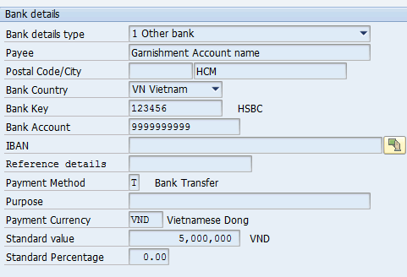

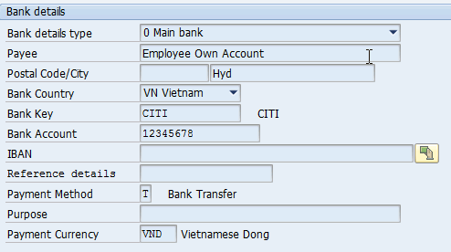

For above input, result will be as below:-

Example: An employee net Pay is 25,000,000 VND and ‘1 – Other bank’ record is saved with 5,000,000 VND. In Bank file, employee will have two split as below

1. 20,000,000 VND against Main Bank account
2. 5,000,000 against Other bank account

Holiday Calendar
Public holiday calendar for each region is part of standard configuration. Details requiring attention include the Substitution Rule determining the action in the event that a public holiday falls on a Saturday or Sunday (i.e. move to previous/next day), or any company-specific holiday information or rules concerning absences on days adjacent holidays.

Public Holiday Name | Year 2015 | Fixed/Movable | Guaranteed | Substitution rule
New Year | 1 Jan | Fixed | Yes | move to next day
Lunar New Year | 18 Feb | Movable | Yes | move to next day
Lunar New Year | 19 Feb | Movable | Yes | move to next day
Lunar New Year | 20 Feb | Movable | Yes | move to next day
Lunar New Year | 23 Feb | Movable | Yes | move to next day
Lunar New Year | 24 Feb | Movable | Yes | move to next day
Hung King's Day | 28 Apr | Movable | Yes | move to next day
Victory Day | 30 Apr | Fixed | Yes | move to next day
International Labour Day | 1 May | Fixed | Yes | move to next day
Independence Day | 2 Sept | Fixed | Yes | move to next day

Every year November, new holiday calendar configuration activities will be initiated by ADP..

Work Patterns
Work patterns within the system determine an employee’s expected specific work hours and public holidays (see above). Work patterns are used in:
- Counting of leave
- Calculation of pay for new hires/ leavers/ unpaid leave
A work pattern consists of a number of components:
- Daily Work Schedules – representing start-, end- , and break-time for each working day
- Period Work Schedules – representing a pattern of daily work schedules.
- Work Schedule Rules – consist of period work patterns, public holiday calendars and informational values such as Daily Working Hours/ Weekly Working hours,. etc.
For Cargill Vietnam, the daily work schedules will be as follows:
Daily WS | Text | Start Time | End Time | Break 1 Start | Break 1 End | Break Paid/ Unpaid | Total Hours Paid
8800 | 8:30, 8 Hr/d | 8:30 | 17:00 | 12:00 | 12:30 | Unpaid | 8
OFF | OF | NA | NA | NA | NA | NA | NA

The period work schedules will be as follows:

Period WS | Text | Seq No | Monday | Tuesday | Wednesday | Thursday | Friday | Saturday | Sunday
1S00 | Mon to Fri | 001 | 8800 | 8800 | 8800 | 8800 | 8800 | OFF | OFF

The work-schedule rules will be as follows:
WSRule | Text | PH Calendar | Daily Working Hours | Weekly Working Hrs | Weekly Working Days | Monthly Working Hrs | Annual Working Hrs
S540000 | Monday to Friday | ;1 | 8 | 40 | 5 | 173.33 | 2080

The assignment of these work schedules to the Cargill Vietnam, Company Codes will be as follows:

WSRule | Co Code
S540000 | VN10
S540000 | VN20

Absences
Absences in the ADP GlobalView are measured by variances to the work patterns. They also affect whether an employee is paid during absences and also the amounts and the formulae that will be used to calculate pay. The following absences will be created for Cargill Vietnam.

Leave Type | Leave Type Text
1000 | Annual Leave
1100 | Sick Leave (SI)
1150 | Sick Leave - Maternity (SI)
1200 | Maternity Leave (SI)
1250 | Adoption Leave (SI)
1300 | Prenatal Leave
1400 | Paternity Leave
1500 | Marriage Leave - Own
1600 | Marriage Leave - Children
1700 | Compensation Leave
1800 | Compassionate Leave
3000 | Unpaid Leave (Short Term)
3100 | Unpaid Leave (Long Term)

- 1000 – Annual Leave: - Annual Leave is paid leave and during this leave period employee will receive salary as usual. Annual leave days will be reduced from Annual leave quota.
- 1100 – Sick Leave (SI): - Sick Leave is considered as paid leave however there is a specific calculation during this leave period. Please refer calculation rule mentioned under “Payment” header. During Sick leave period, employee will receive Gross salary as usually however Basic Salary will be split into Basic pay and Sick Pay. Sick Leave days will be reduced from Sick Leave quota.
- 1150 – Sick leave – Maternity (SI): - Sick Leave Maternity is considered as paid leave however there is a specific calculation during this leave period. Please refer calculation rule mentioned under “Payment” header. During Sick leave period, employee will receive Gross salary as usually however Basic Salary will be split into Basic pay and Sick Pay - Maternity. Sick Leave days will be reduced from Sick Leave quota.
- 1200 Maternity Leave (SI): - Maternity Leave is considered as unpaid leave and during this leave period salary will be prorated/unpaid. Example: An employee starting her maternity leave on 13th July 2015. Basic Salary is 25,000,000 and Car Allowance is 5,000,000. July 2015 salary will be prorated as below
Basic Salary = 25,000,000 / 23 * 8 = 869,5652 VND
Car Allowance = 5,000,000 / 23 * 8 = 1,739,130 VND
- 1250 Adoption Leave (SI): - Adoption Leave is considered as unpaid leave and during this leave period salary will be prorated/unpaid. Example: An employee starting her adoption leave on 13th July 2015. Basic Salary is 25,000,000 and Car Allowance is 5,000,000. July salary will be prorated as below
Basic Salary = 25,000,000 / 23 * 8 = 8,695,652 VND
Car Allowance = 5,000,000 / 23 * 8 = 1,739,130 VND
- 1300 – Prenatal Leave: - Prenatal leave is considered as paid leave and however there is a specific calculation during this leave period. Please refer calculation rule mentioned under “Payment” header. During prenatal leave period, employee will receive Gross salary as usual however Basic Salary will be split into Basic pay and Prenatal Leave.
- 1400 – Paternity Leave: - Paternity leave is considered as paid leave and during this leave period employee will receive salary as usual. No Impact to Payroll or Payslip.
- 1500 – Marriage Leave Own: - Marriage Leave Own is considered as paid leave and during this leave period employee will receive salary as usual. No Impact to Payroll or Payslip.
- 1600 – Marriage Leave Children: - Marriage Leave Children is considered as paid leave and during this leave period employee will receive salary as usual. No Impact to Payroll or Payslip.
- 1700 – Compensation Leave: - Compensation Leave is considered as paid leave and during this leave period employee will receive salary as usual. No Impact to Payroll or Payslip.
- 1800 – Compassionate Leave: - Compassionate Leave is considered as paid leave and during this leave period employee will receive salary as usual. No Impact to Payroll or Payslip.
- 3100 – Unpaid Leave - During this leave period salary will be prorated/unpaid. Example: An employee starting his Unpaid leave form 13th July 2015 to 22nd July 2015 . Basic Salary is 25,000,000 and Car Allowance is 5,000,000. July 2015 salary will be prorated as below
Basic Salary = 25,000,000 / 23 * 15 = 16304348 VND
Car Allowance = 5,000,000 / 23 * 15 = 3260870 VND
If employee is in full month unpaid leave, Public Holiday will not be paid. However if employee worked atleast 1 day in a month, Public holiday will be paid to employee.

Please refer Blueprint Configuration workbook Absence Tab for more details

Absence Quotas
Absence Quotas provide the ability to track the number of annual leave days that the employee has remaining for the current period from categories of leave, for example:
50 Annual Leave
The following absence quotas will be configured for Cargill Vietnam
Quota Type | Text
50 | Annual Leave
51 | Annual Leave c/f
60 | Sick Leave

Quota 50 – Annual Leave

1. Entitlement will be based on employee service year. This entitlement is applicable only for EE group 1 – Permeant and EE group X - Expat

. From 0 to 3 years: 14 days
. Above 3 years to 6 years: 15 days
. Above 6 years to 9 years: 16 days
. Above 9 years to 12 years: 17 days
. Above 12 years to 15 years: 18 days
. Above 15 years: 20 days

For casual and Temporary employees, 1 day per month will be credited if they are active on 15th of the month. No upfront entitlement for these two group of employee. In case EE moved to Permanent, AL will be re-calculated on transfer day however Leave Anniversary calculation, original hire date will be considered.

2. No Entitlement will be calculated for EE group I - Inpat (Inbound) employees since they follow home country leave policy. Above Leave entitlement will be applicable to all employees except Inpat.

3. Leave will be entitled only after Probation date is completed. Cargill needs to load Probation End date for all employees in date type; 3 in IT0041. Let say if an employee do not have probation end date, please maintain this date type with hire date.

3. If employee joined after 1st June, entitlement will be prorated. Proration Logic is Entitlement Days / 12 * Number of month’s upto May. If employee joined after 15th of the month, then joining month will not be considered for calculating prorated leave eligibility.

Example: Employee Joined 17th June 2015 and probations end date is 16th Sep 2015. On 16th Sep 2015, Annual leave credited t to employee account will be 14 / 12 * 11 = 13 Days (12.83 rounded to 13 days). Since employee joined after 15th Of June 2015, June month is not considered for entitlement calculation

5. Termination: If employee terminated during leave base period, entitlement will be prorated. Proration Logic is Entitlement Days / 12 * number of months worked. If employee terminated before 15th of the month, then that month will not be considered for entitlement.

Example: An employee has 10 Years service and Employee Terminated on 14th Feb 2016. Prorated annual leave entitlement will be 17 / 12 * 6 = 8.5 days. Since employee terminated before 15th of the month, Dec 2015 will not be considered for Annual leave entitlement.

6. Entitlement will be based on 1st June service Year. During the base period, if employee reach anniversary milestone, 1 day additional entitlement (As per Seniority slab) will be given to employee on anniversary day. Employee is no need to wait till next cycle to get the revised eligibility.

8. During termination payroll, annual leave balance will be paid as encashment and leave balance will be made as zero.

Quota 51 – Annual Leave c/f

Annual leave balance of previous cycle with cap of 5 days will be carry forward to current cycle in every June. Validity period for annual leave c/f is one year. During this cycle, if an employee applied annual leave, leave days will be deducted first from annual leave c/f quota and remaining days will be reduced from Quota 50 – annual leave.
Quota 60 – Sick Leave

Every 1st January or on hire date Sick leave entitlement 30 days will be credited to employee account.

Social Insurance
Social Insurance is a legislative requirement in Vietnam. All new employees are set up in the company fund as a default rate.
List of Social Insurance details:
Insurance Type |  | Insurance Scheme Text |  | EE % Contribution |  |  | ER % Contribution
01 |  | Compulsory Social Insurance |  | 8% |  |  | 18%/ 17%  27,800,000 (applied from 1 July 2018 to 30 June 2019)
03 |  | Unemployment Insurance (用的是区域MW，另外两个是用GMW 全国的平均) |  | 1%/ |  |  | 1% /
04 |  | Health Insurance |  | 1.5% /(1,5%) |  |  | 3% /(1,5%)
 | ER |  | Social insurance |  | Health insurance | Unemployment insurance |  | TOTAL
 | Current |  | 18%  In which:  - 3% to the sickness and maternity fund  - 1% to the labor accident and occupational disease fund  - 14% to the retirement and survivorship allowance fun |  | 3% | 1% |  | 22%
 | From June, 2017 |  | 17.5%  In which:  - 3% to the sickness and maternity fund  - 0.5% to the labor accident and occupational disease fund  - 14% to the retirement and survivorship allowance fun |  | 3% | 1% |  | 21.5%

The SI contribution of employee and employer is based on contract salary but capped at 20 times of the “general minimum wage” (GMW). Below is a table of general minimum wage * 20. The Minimum salary changes according to the State Rule, this could occur annually or every 2 years
From date | To date | GMW * 20
01.07.2013 | 31.12.9999 | 23,000,000

For UI contribution below capping will be applied based on employee location.

From date | To date | Minimum Salary | Minimum Salary * 20 | Area Salary Code
01.01.2015 | 31.12.9999 | 3,100,000 | 62,000,000 | _MNS1
01.01.2015 | 31.12.9999 | 2,750,000 | 55,000,000 | _MNS2
01.01.2015 | 31.12.9999 | 2,400,000 | 48,000,000 | _MNS3
01.01.2015 | 31.12.9999 | 2,150,000 | 43,000,000 | _MNS4

Psub Area | Psub Area Text | Area Salary Code | Amount | Payroll Constant
VN01 | Bien Hoa | Zone 1 | 3,100,000 | _MNS1
VN02 | Binh Dinh | Zone 3 | 2,400,000 | _MNS3
VN03 | Can Tho | Zone 2 | 2,750,000 | _MNS2
VN04 | Daklak | Zone 3 | 2,400,000 | _MNS3
VN05 | Dong Thap | Zone 4 | 2,150,000 | _MNS4
VN06 | Ha Nam | Zone 3 | 2,400,000 | _MNS3
VN07 | Hanoi | Zone 1 | 3,100,000 | _MNS1
VN08 | Ho Chi Minh | Zone 1 | 3,100,000 | _MNS1
VN09 | Hung Yen | Zone 2 | 2,750,000 | _MNS2
VN10 | Long An | Zone 2 | 2,750,000 | _MNS2
VN11 | Tien Giang | Zone 3 | 2,400,000 | _MNS3
VN12 | Vinh | Zone 3 | 2,400,000 | _MNS3
VN13 | Ben Cat | Zone 1 | 3,100,000 | _MNS1
VN14 | Bac Giang | Zone 3 | 2,400,000 | _MNS3
VN15 | Vung Tau | Zone 1 | 3,100,000 | _MNS1

Changes related to the statutory constants are part of legislation updates would be incorporated automatically in the system.
If employee’s contract salary WT9CON is lower than 23,000,000, the amount in WT9CON will be used to calculate social insurance. If the amount in WT9CON is higher than 23,000,000, the amount will be capped to 23,000,000 to calculate social insurance.
Examples for Social Insurance
Example 1:
Employee’s Notional Salary for Social Insurance Base WT 9CON is 15,000,000 VND.
Since this amount 15,000,000 is below the capping amount 23,000,000 VND, 15,000,000 is used as Social Insurance base. So, calculation will be,
15,000,000 VND * 8% (for EE part of CSI) = 1,200,000 VND
15,000,000 VND * 18% (for ER part of CSI) = 2,700,000 VND
15,000,000 VND * 1% (for EE part of UI) = 150,000VND
15,000,000 VND * 1% (for ER part of UI) = 150,000 VND
15,000,000 VND * 1.5% (for EE part of HI) = 225,000 VND
15,000,000 VND * 3% (for ER part of HI) = 450,000 VND

Example 2
Employee’s Notional Salary for Social Insurance Base WT 9CON is 24,000,000 VND. Since this amount is above the capping amount, the capping amount (23,000,000) is used as Social Insurance base. So, calculation will be,
23,000,000 VND * 8% (for EE part of CSI) = 1,840,000VND
23,000,000 VND * 18% (for ER part of CSI) = 4,140,000VND
25,000,000 VND * 1% (for EE part of UI) = 250,000 VND [ Assume capping is 48,000,000 ]
25,000,000 VND * 1% (for ER part of UI) = 250,000 VND [ Assume capping is 48,000,000 ]
23,000,000 VND * 1.5% (for EE part of HI) = 345,000VND
23,000,000 VND * 3% (for ER part of HI) = 690,000VND
New Hire and Termination
If employee hires from 1st to 15th of the month, employee SS contribution will be paid in hiring month based on full month SS base.
If employee hires from 16th to 31st of the month, employee SS contribution will only start from following month. There is no retro calculation for previous hiring month.
If employee’s last working day is on or before 14th of the month, employee will not have SS contribution for termination month.
If employee’s last working day is from 15th to 31st of the month, employee will be subjected to SS contribution in termination month.
Probation Cases – IT9521 data maintains.
During probation period, SS will not be contributed however if employee pass probation, Cargill will contribute SS from hire month. This requirement is managed in system thru IT9521 data maintains.
SAP will calculate SI only if field “Calculate contribution” field is flagged. Let say an employee hire date is 1st Feb 2015 and Probation End date is 31st March 2015. When employee hired on 1st Feb 2015, IT9521 record should be loaded without flag in Calculate Contribution filed as shown below.
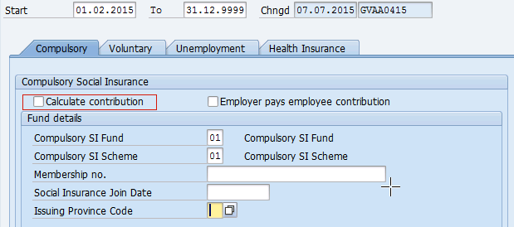
During April 2015, IT9521 needs to be re-loaded with effective date as 01.02.2015 and with flag in Calculate contribution field as shown below.
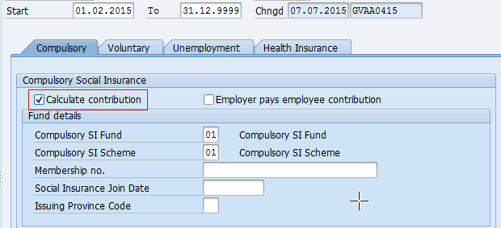
In April 2015 payroll, system re-calculate SI from Feb 2015 and deduct/contribute to SI agency.
Maternity Leave and Unpaid Leave Cases
Maternity Leave

SS should not be contribute for 6 months during maternity leave (single birth), as below.
- If employee maternity leave is start from 1st to 14th of the month, employee will not have SS contribution for maternity month and the next 5 months, total period of 6 months.
- If employee maternity leave is start from 15th to 31st of the month, employee will be subjected to SS contribution in maternity month. However, there will be no SS contribution for the next 6 months.
- If the EE comes back from maternity leave between 1st to 14th of the month then the EE would contribute towards SS
- If the EE comes back from maternity leave between 15th to 31st of the month then there is no SS contribution for that month
E.g. Single birth:
(a) Maternity starts 13.11.2014
No SS contribution from Nov 2014 to Apr 2015, SS start from May 2015
(b) Maternity starts 17.11.2014
SS contributed for Nov 2014. No SS contribution from Dec 2014 to May 2015

E.g. Twin:

If the maternity is for twin, the maternity period will be for 7 months. No SS contribution for total of 7 months, and SS will resume from the 8th month onwards

(a) Maternity starts 13.11.2014
No SS contribution from Nov 2014 to May 2015, SS start from Jun 2015
(b) Maternity starts 17.11.2014
SS contributed for Nov 2014. No SS contribution from Dec 2014 to Jun 2015

In case of multiple births the leave record also has to be updated in the system so that the system would stop the SS in case of maternity leave.

Note: Early Return maternity leave - after the 4th month of maternity, Cargill will continue to pay only the salary. No SS contribution until the 7th month or 8th month (twin)

In such cases where the EE returns early from maternity leave, then for the period for which the SS contribution should not happen, the IT 9521 Social Insurance record should be delimited accordingly. The check box for the SI contribution should be un ticked so that system would not contribute towards the SS

Following two leave type will be used for below calculation.
Leave Type | Leave Type Text
1200 | Maternity Leave (SI)
1250 | Adoption Leave (SI)
Note to Configure: - Include above two absence type in feature -VNML

Unpaid leave
If employee has taken 14 working days unpaid leave (leave type 3000 & 3100) in a month, that month will not have SS contribution.
Note to Configure: - Include above two absence type in feature -VNUL

Insurance Base Retro:
Any retrospective calculation which impacts the social insurance base will cause the social insurance to be recalculated for retro month and the difference will contribute in current month.
Employee Mar salary WT1000 is 6,050,000.
Employee Apr salaryWT1000 increases to 7,000,000 with backdated to Mar 1.
The social insurance base difference of Mar is 7,000,000 -6,050,000 = 950,000.
The social insurance difference is 76000 for CS; 9500 for UI; 14,250 for HI. They will be contributed on top of Apr insurance.
Social Insurance Infotype – 9521
Social insurance infotype will look as below and this infotype is mandatory for all employee irrespective whether they contribute to SI or not. In case employee is not contributing to SI, you can remove the flag from field, “Calculate contribution”.

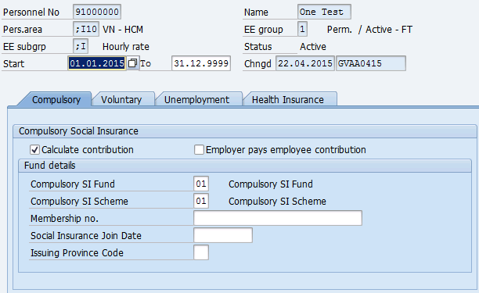

Technical WT Reference

Full names of the abbreviations are provided for reference

Technical WT's
Statutory EE and ER Contributions | WT Text | Description
/320 | CSI EE Contribution | Compulsory Social Insurance Employee Contribution
/321 | CSI ER Contribution | Compulsory Social Insurance Employer Contribution
/340 | UI EE Contribution | Unemployment Insurance Employee Contribution
/341 | UI ER Contribution | Unemployment Insurance Employer Contribution
/350 | HI EE Contribution | Health Insurance Employee Contribution
/351 | HI ER Contribution | Health Insurance Employer Contribution

Taxation
Taxation is a legislative requirement in Vietnam. Please refer to excel file.
Personal Sub Area | Tax Office | Tax office Text | Company Tax ID

Tax Rate
Monthly Tax will be calculated in system either in Progressive Tax Rate or Flat Tax rate based on the combination maintained in Info Type 9520. Below are the 12 combination will be configured in system and Cargill need to maintain applicable combination to employee to get the correct tax deduction.
ADP Fields | Combination A | Combination B | Combination C | Combination D
Nature Of Person | 01 Resident | 01 Resident | 01 Resident | 01 Resident
Nationality | 01 Vietnamese | 01 Vietnamese | 01 Vietnamese | 02 Foreigner
Employment Category | 01 Labor Contract | 02 W/O Labor Contract | 03 Probation | 01 Labor Contract
Result | Progressive Tax Rate | 10% Flat Rate | 10% Flat Rate | Progressive Tax Rate
Lower Bound of Income per Month |  | If taxable income is <2,000,000, no Tax will be deducted | If taxable income is <2,000,000, no tax will be deducted

ADP Fields | Combination E | Combination F | Combination G | Combination H
Nature Of Person | 01 Resident | 01 Resident | 02 Non-Resident | 02 Non-Resident
Nationality | 02 Foreigner | 02 Foreigner | 02 Foreigner | 02 Foreigner
Employment Category | 02 W/O Labor Contract | 03 Probation | 01 Labor Contract | 03 Probation
Result | 10% Flat Rate | 10 % Flat Rate | 20% Flat Rate | 20 % Flat Rate
Lower Bound of Income per Month | If taxable income is <2,000,000, no tax will be deducted | If taxable income is <2,000,000, no tax will be deducted | NA - Flat rate | NA - Flat rate

ADP Fields | Combination I | Combination J | Combination K | Combination L
Nature Of Person | 03 Resident w/o taxcode | 03 Resident w/o taxcode | 03 Resident w/o taxcode | 03 Resident w/o taxcode
Nationality | 01 Vietnamese | 01 Vietnamese | 01 Vietnamese | 02 Foreigner
Employment Category | 01 Labor Contract | 02 W/O Labor Contract | 03 Probation | 01 Labor Contract
Result | Progressive Tax Rate | 10% Flat Rate | 10% Flat Rate | Progressive Tax Rate
Lower Bound of Income per Month |  | If taxable income is <2,000,000, no tax will be deducted | If taxable income is <2,000,000, no tax will be deducted

Vietnam Tax infotype 9520 will looks as below
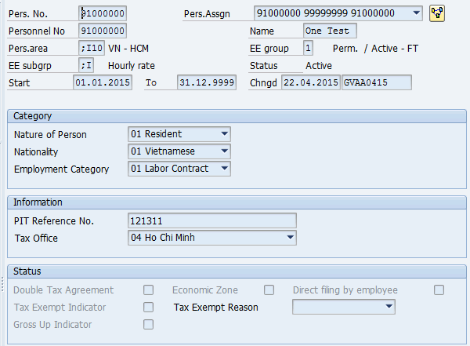
Dependents constants
Personal Ded. /M | Personal Ded. /Y | Dependent Ded./M | Dependent Ded./Y
9,000,000 | 108,000,000 | 3,600,000*N | 43,200,000*N

Tax Rate
Tax level | Yearly Taxable Income | Tax rate (%) | Tax on Income: Year
1 | Up to 60 | 5 | 0
2 | Over 60 up to 120 | 10 | 3,000,000
3 | Over 120 up to 216 | 15 | 9,000,000
4 | Over 216 up to 384 | 20 | 23,400,000
5 | Over 384 up to 624 | 25 | 57,000,000
6 | Over 624 up to 960 | 30 | 117,000,000
7 | Over 960 | 35 | 217,800,000

Any changes to the above constant will be updated automatically in system as part of legal update.

Tax Calculation method
The tax calculation methods that are applicable are
- Progressive Tax Rate
- Flat % Tax Rate
Progressive Tax calculation method
Say the EE has 2 dependents, monthly taxable income = 72,915,000 and falls in progressive tax rate method
Step 1 : Calculate annual equivalent
Taxable earnings - month to date 72,915,000 (i.e. /106 Taxable Income in that month)
Tax periods in year 12 (i.e. No of months in a year)
Annual Taxpayer Deduction 108,000,000 (constant)

Dependent exemption
Dependent(s): 02
Annual Dependent Deduction per dependent 43,200,000
Total Annual Dependent Deduction: 86,400,000 = 43,200,000 * 02

Annual taxable income: 874,980,000 = 72.915.000 * 12
Annual taxable income after deductions: 680,580,000 = 874.980.000 – 108,000,000 – 86,400,000

Step 2: Calculate tax deduction

Annual equivalent: 680,580,000
Bracket lower base: 624,000,000 (as per the table provided above)
Tax on bracket lower base: 117,000,000(as per the table provided above)
Tax rate on bracket: 30(as per the table provided above)
Tax periods in year: 12

Taxable value greater than bracket: 56,580,000 = 680,580,000 – 624,000,000
Tax on value greater than bracket: 16,974,000 = 56,580,000 * 30 %
Annual tax: 133,974,000 = 16,974,000 + 117,000,000
Period tax: 11,164,500 = 133,974,000 / 12

Monthly Tax: 11,164,500

Flat Rate Method
Step 1: Calculate annual equivalent
Taxable earnings - month to date 72,915,000(i.e. /106 Taxable Income in that month)
Tax periods in year: 12

Annual Taxpayer Deduction: 0
Per Period Deduction per dependent:
Dependent(s): 04
Annual Dependent Deduction per dependent 0
Total Annual Dependent Deduction: 0 = 0 * 04

Annual taxable income: 874,980,000 = 72,915,000 * 12
Annual taxable income after deductions: 874,980,000 = 874,980,000 - 0 - 0

Step 2: Calculate tax deduction

Annual equivalent: 874,980,000
Bracket lower base: 24,000,000
Tax on bracket lower base: 2,400,000
Tax rate on bracket: 10.00
Tax periods in year: 12

Taxable value greater than bracket: 850,980,000 = 874,980,000 - 24,000,000
Tax on value greater than bracket: 85,098,000 = 850,980,000 * 10.00 %
Annual tax: 87,498,000 = 85,098,000 + 2,400,000
Period tax: 7,291,500 = 87,498,000 / 12

Tax: 7,291,500

Based on the data maintained in the IT 9520 the tax method gets applied.

Year End Tax Calculation:
Tax Finalization is the Year End process for Vietnam.
SAP will recalculate tax for all employees including new hire but excluding terminated employees. New hire and terminated employees will be included into 05/KK-TNCN report. For employees who should not be included in Tax Finalization, Cargill should flag “direct filing” field in IT9520

Sample calculation of Tax finalization is attached for your references.

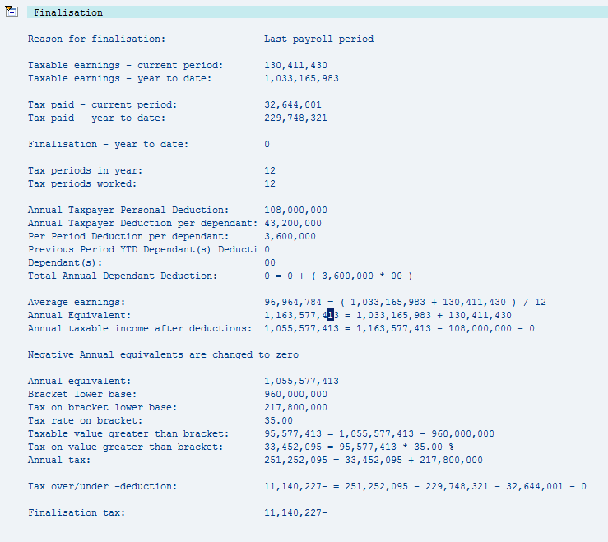

Tax finalization will be configured for Cargill in every “January” Payroll. During Tax finalization, Tax on Benefit wagetypes which employer bear tax cost will be recalculated and paid to back employees.

ER Pay Tax wagetypes

Below benefit wagetypes tax will be borne by employer. Cargill will input below wagetypes in monthly payroll.
ER Pay Tax
4025 | Child Edu Support
4030 | Company Trip
4035 | Family Day
4055 | Gift
4060 | Helmet

Employer tax portion of this wagetypes will be generated in WT 4061 in monthly payroll and will be paid to employees. Tax on above wagetypes will be deducted from employee thru regular tax wagetype (/400) hence net tax impact for the employee is Nil

WT4061 Employer Pay Tax-Monthly Logic will be as below.

- First calculate Monthly Tax after excluding above 5 benefit WT’s.
- Calculate the Monthly Tax after including above 5 benefit WT’s
- Difference of Step 2 minus Step 1 will be WT4061.

During Tax Finalization in every January, system will recalculate Employer Tax Portion on this 5 wagetypes and adjust employer Pay tax amount paid to employees thru WT4062 - ER Pay Tax – Finalization

WT4062 ER Pay Tax – Finalization Logic will be as below
- First calculate annual Tax on YTD taxable income after excluding above 5 benefit WT’s YTD amount.
- Calculate annual tax on YTD taxable income after including above 5 benefits WT’s YTD amount.
- Find the difference of Step 2 and Step 1. From this amount, minus WT4061 YTD amount. This result will be WT4062

House Lease Benefit – Taxable Calculation (added on 14.08.2015)

House rental that the company paid to the landlord is added to his taxable income but the taxable rental amount should not exceed 15% of his monthly total taxable income.

The taxable income from house rental = (taxable earnings (excl. house rental) x 15% = VND or which ever is less

Say the master data of the EE is as below

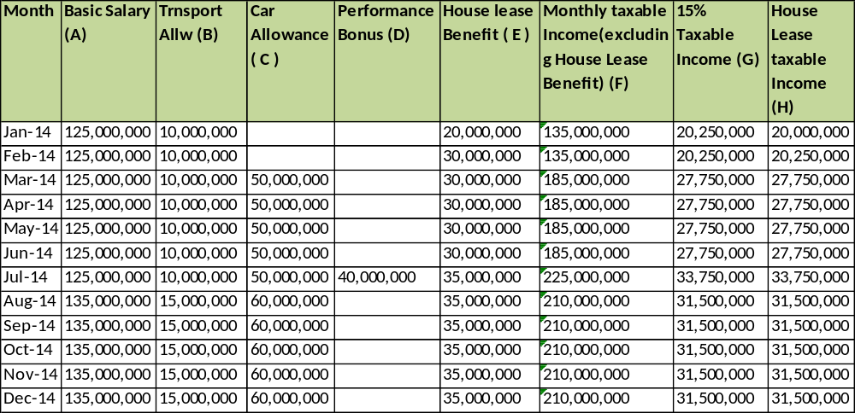

A Monthly Basic salary of the EE
B Monthly Transport Allowance
C Monthly Car Allowance
D Adhoc Bonus component
E House Lease Benefit paid to the EE outside of payroll and inputted in notional WT
F Total Monthly Taxable Income A+B+C+D
G Monthly Taxable Income * 15% i.e. F *15%
H House Lease Taxable Income = min of 15% Taxable Income and House Lease Benefit i.e. Minimum of G & E

So in a month the final taxable income is F + H. So for the month of Jan-14 the total taxable income including the house lease benefit is 135,000,000 + 20,000,000 = 155,000,000

Sample House rental taxable Calculations

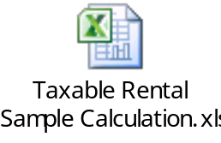

System would re compute the taxable house lease benefit based on the updated Taxable Income and will adjust accordingly in May Payroll. Hence when ever there are any retrospective changes in either the WT 4015 House Lease Benefit or the components part of the taxable income then the house lease taxable income also gets adjusted accordingly

Banking
Insert brief description of all the bank accounts that employee pay is sent from.
For example:
- Company A pays from Citibank Direct Online Facility.
- Company B pays from Citibank Direct Online Facility.

Name of Bank | Bank Country | Swift Code | Bank Key | Account No | Account Name
Deutsche Bank Ho Chi Minh | VN | DEUTVNVXXXX | 79619001 | 100.2641.050 | Công Ty TNHH Cargill Viet Nam
HSBC Bank | VN | HSBCVNVX | 79617001 | 001-636752-001 (VND) | CTY TNHH MTV PROVIMI
HSBC Bank | VN | HSBCVNVX | 79617001 | 001-636752-101 (USD) | CTY TNHH MTV PROVIMI
HSBC Bank | VN | HSBCVNVX | 79617001 | 001-636752-108 (EUR) | CTY TNHH MTV PROVIMI

Please refer to the worksheet for specific details of the bank accounts and their relevant information.

General Ledger
The Standard SAP General Ledger posting configuration will be utilized. Please refer to the worksheet for details on General Ledger postings.

Cargill will have two GL grouping as below
COGS – Cost of Goods Sold
SGA – Sell, General & Admin
This identification will be stored in P0001-VDSK1 Organizational Key for employees.

Finance Team needs to map the each wagetype to a GL account in GL posting tab of the configuration workbook.

User Access
This section defines the level of required access for different users / roles within Cargill Vietnam.
Separate authorization matrix file will be released later stage of the project.
Please refer also the latest ADP authorisation matrix document, SAP User Menu Template for ECC5 ASIA PACIFIC (GV00000095), for the available generic and AU-specifc authorization roles and details.

Configuration Worksheet
The following attachment contains the client-specific copy of the Configuration Worksheet, containing details of the technical settings for the configuration of the system. Please do not make changes to this worksheet, but advise changes in this word document only.
< Insert current copy of Blueprint Configuration Worksheet
Reports Provided
- Following reports will be generated and provided to Cargill every month during payroll period as part of Trial Pay Run reports for reconciling the payroll result and sign off.

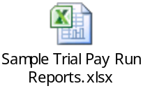
- Cargill needs certain set of reports to meet internal reporting requirement. ADP will support / train Cargill HR users to set report variant in system as and when required. Please note that report variant/format will be set up only within standard Global view report like payroll register, wage type reporter, ad hoc query etc. It’s not included and covered custom developed reports.
Sample report variant to be set up in system is attached for references. During parallel run, we will set up these report variant in system and Cargill system users can generate this report and verify before setting up this variant in production.

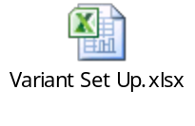
- The embedded word document below shows the reports that will be provided as part of the GlobalView service. Please note the Payroll Procedures Manual will define when the reports will be provided to you in the payroll process. These examples have been downloaded in .PDF, TXT and EXCEL format for the purposes of this document, however, the standard options for most report/ file downloads within the ADP Solution are:
- Unconverted
- Spreadsheet
- RTF (Rich Text Format)
- HTML
The Document groups reports by:-
- HR Master Data Reports
- Time Management Reports
- Employee Self Service (ESS) Reports
- Generic Payroll Reports

Details of all reports are provided in GV00000396 APAC SAP HR-Payroll Reports available separately.


Country Specific Reports
All - Vietnam specific reporting is compliant with the required Federal Laws including information and format based requirements. A short description of each report provided follows.

Period Reports
Report | Transaction code | Description
Social Insurance – Newcomers | /EPIUSE/HVNCSIN1 | New Staffs join the social insurance and health insurance company
Social Insurance – Leaver & Change | /EPIUSE/HVNCSIN2 | Terminate staffs or change the social insurance and health insurance information
Declaration of Regular PIT | /EPIUSE/HVNCPIT1 | Monthly tax declaration of remit  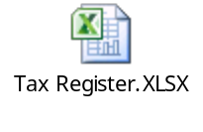

Year End Reports
Report | Transaction code | Description
Finalization Declaration of PIT | /EPIUSE/HVNCPIT2 | Declaration for annual tax finalization

Details of all reports are provided in GV00000 Sample Reports in PDF available separately.

Payslip
The payslip program enables you to print a payslip in hard copy format for employees.
Please note, the format of the hard copy payslip is the same as the format provided for ESS Use. For Cargill Vietnam, payslip logo will be printed based on legal entity. Please refer Configuration workbook Tab Payslip for details.
Employee Self Service
Separate blueprint will be released.

Interfaces

The Client will send the following inbound interfaces
G2 interface from OMPA (Cargill HR system based on SAP)

ADP will provide the following outgoing interfaces –
General Ledger
JDE format
Bank File
HSBC and DB format
The specifications for these outgoing interfaces are referenced as appendices to this document.
Assumptions/Risks

Assumptions
This Blueprint has been created based on information current at the beginning of 1st June 2015. Where possible, ADP has taken into account possible policy changes, however, it is assumed that what is documented above will be what the User Acceptance Testing and Parallel Runs will be based on. It is also assumed that employees will have access to a computer, if not their own, a kiosk type set-up may be provided.

Risks
There are a number of risks that have been identified during the blueprinting process:
GAP Analysis and Resolution

Missing Functionality
None identified during this Blueprint

System Modifications Required
None Identified during this Blueprint
Appendices
Please list all related specifications and their file names below: - e.g. Bank File Specification Bank Westpac V 1.0.

